**Heaps/Priority queue**

* Heaps are also called priority queue.
* 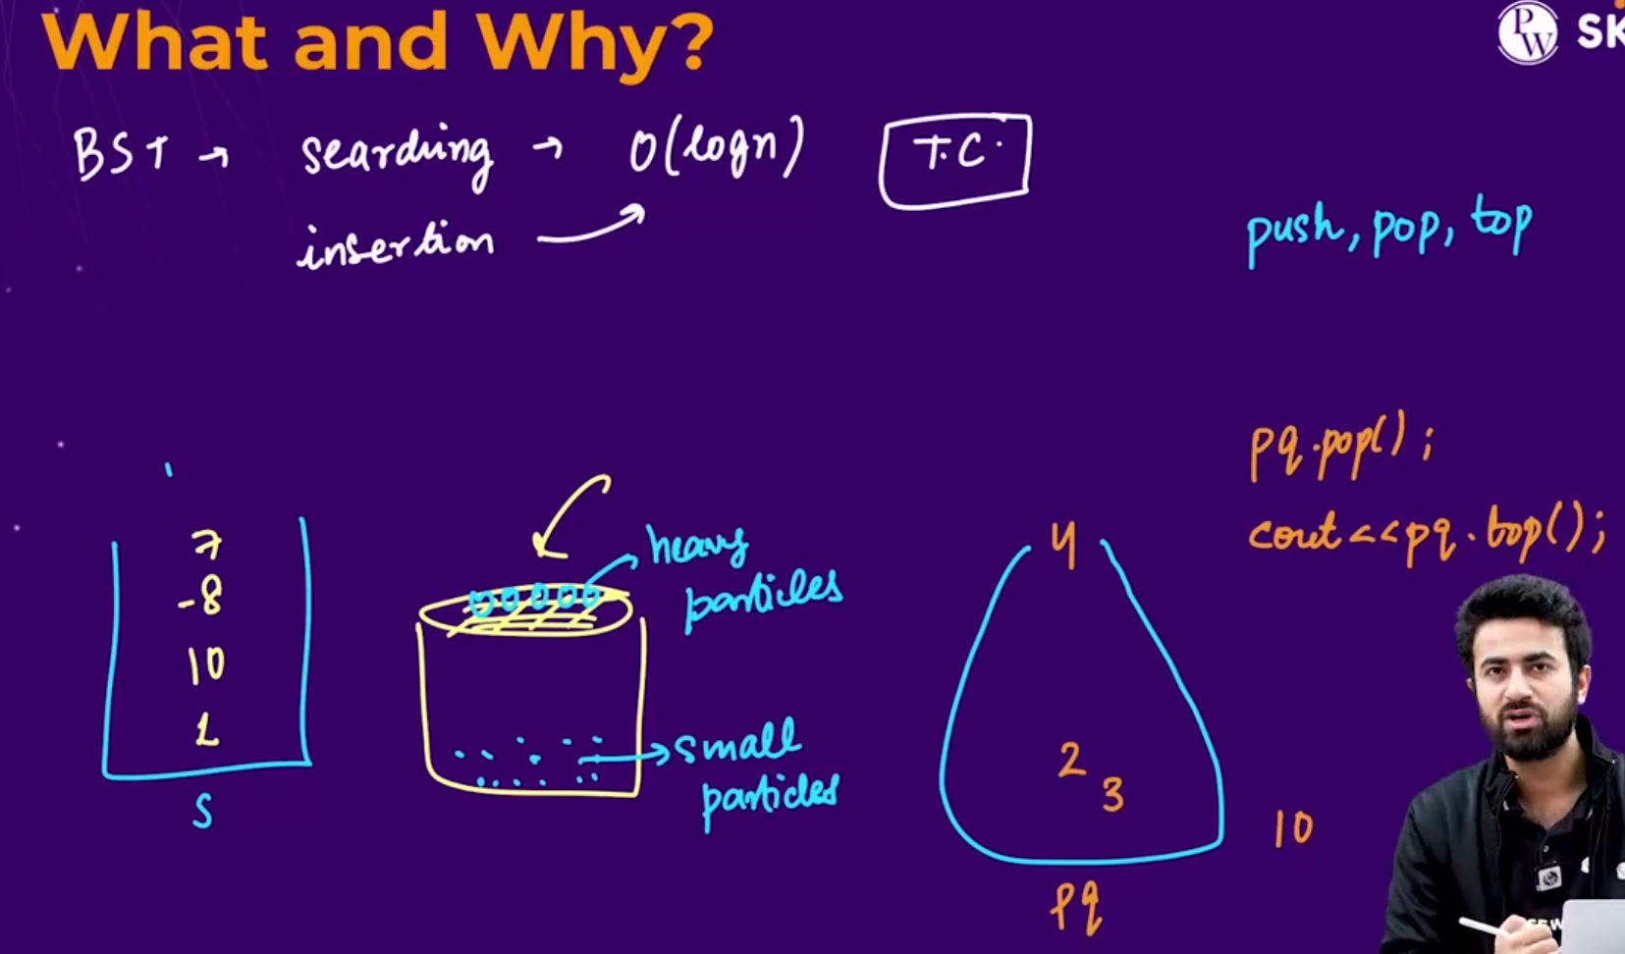🡪heap is similar to stack , it contains all the operations of stack like 🡪 push(), pop(), top()\
  + Heap m bhi hm jo, sbse top m element h usko hi access kr skte h by using **top()** function.
  + **Heap m jo sbse bada element hota h , woh hmesha top m aa jaata h, automatically, but neeche m jitne bhi smaller elements present rhte h jaroori nhi h ki who sorted order m ho, who randomly arranged hote h.**
  + **Eg:** suppose hmne heap se 1st element nikaala (jo ki sbse bada element hoga), then uske baad jo top p element aayega woh neeche jo elements present tha usme se sbse bada element hoga.
  + To include priority queue also , we use 
  + Note:- c++ m by default **maxheap** bnta h.
  + 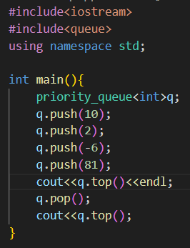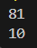🡪in priority queue/heap jo sbse bada element top p present rhta h, whi access kiya jaa skta h and hm ussi ko pop() kr skte h.
* 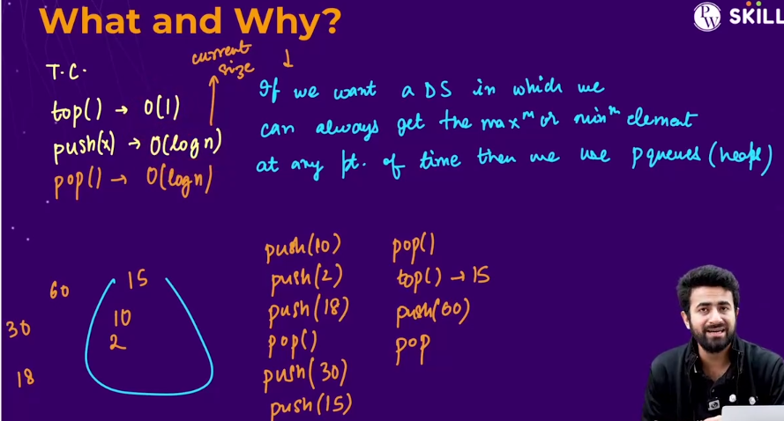🡪if we want to access the maximum or minimum element from the queue then in that case we can use priorityQueue/minheap/Maxheap.
  + Also **to access any element the heap** 🡪 **T.C=O(1).**
  + **To push any element in the heap** 🡪**T.C=O(logn)** 🡪 becoz jb hm push krte h element ko to internal rearrangement hota h due to that T.C= O(logn)
  + **To pop() any element from the heap** 🡪**T.C=O(logn)** 🡪 becoz jb hm pop() krte h element ko to top element i.e sbse bada jo hota h, who pop to ho jaata h, lekin ab neeche se smaller elements m jo sbse woh search hota h and woh top p aa jaata h, due to that internal rearrangement T.C= O(logn)
* 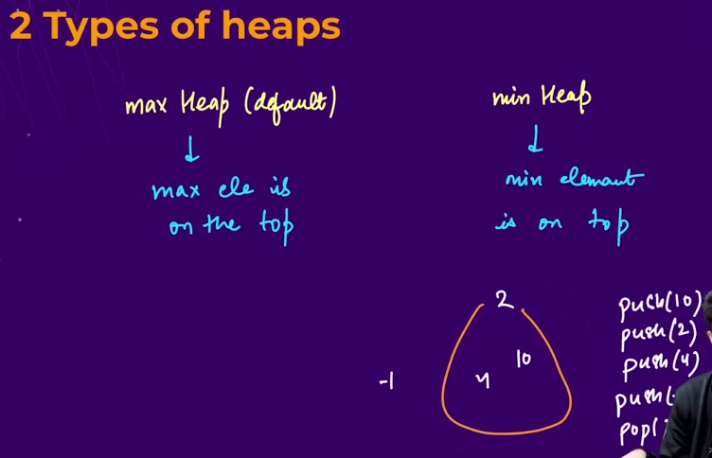
  + Types of Heap:
    - Max heap 🡪by default in c++ max heap is created🡪max element is on top
    - Min heap🡪min element is on top
* 



* To create maxheap🡪
* To create minheap🡪 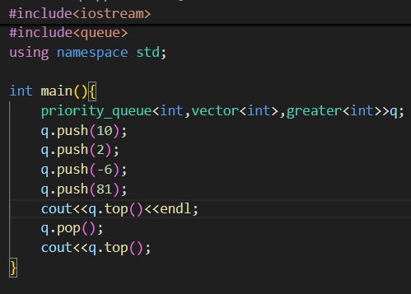 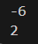



* + Agar hm doosre datatype ka queue bna rhe h, hme tino jagah changes krna hoga, jha **int** likha hua h. (eg: agar hme float datatype ka queue bnaana h then, hm saare int k jagah float likhenge).
* 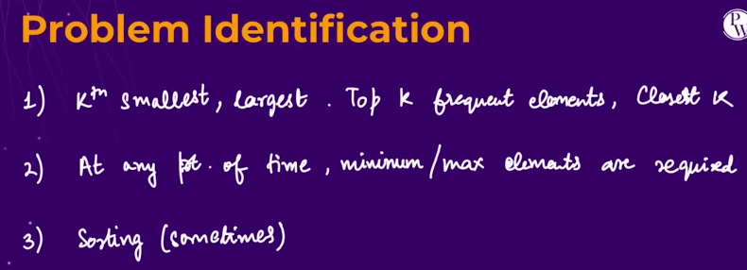🡪in sb type k problems ko hhm heap ki help se solve kr skte h.

`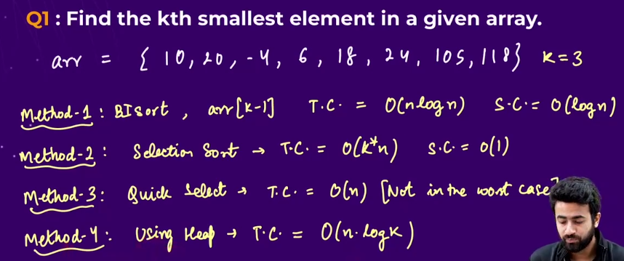

* Method 1🡪 do the internal sorting and then return the element on the [k-1]th index.
  + T.C🡺O(nlogn)🡪 becoz it uses quick sort.
  + S.C🡺O(logn)🡪becoz it uses quick sort.
* Method 2🡪 do the selection sort 🡪in selection sort , in each pass array m se sbse smallest element nikal k aage aa jaata h, so hm k times selection sort k algorithm ko chalaayenge .
  + T.C🡺O(k*n)
  + S.C🡺O(1)🡪becoz it uses no extra space.
* Method 3🡪use quick select algorithm
  + T.C🡺O(n)
* Method 4 🡪using heap
  + T.C🡺O(nlogk)🡪 since “k” is smaller than “n”, so **n*logk** is even smaller than **n*logn**
  + Algorithm🡪**form the minheap🡪not a good algorithm** and pop the elements from the heap for k times and return the last element popped.-->but the time complexity of this method is not **n*logk**

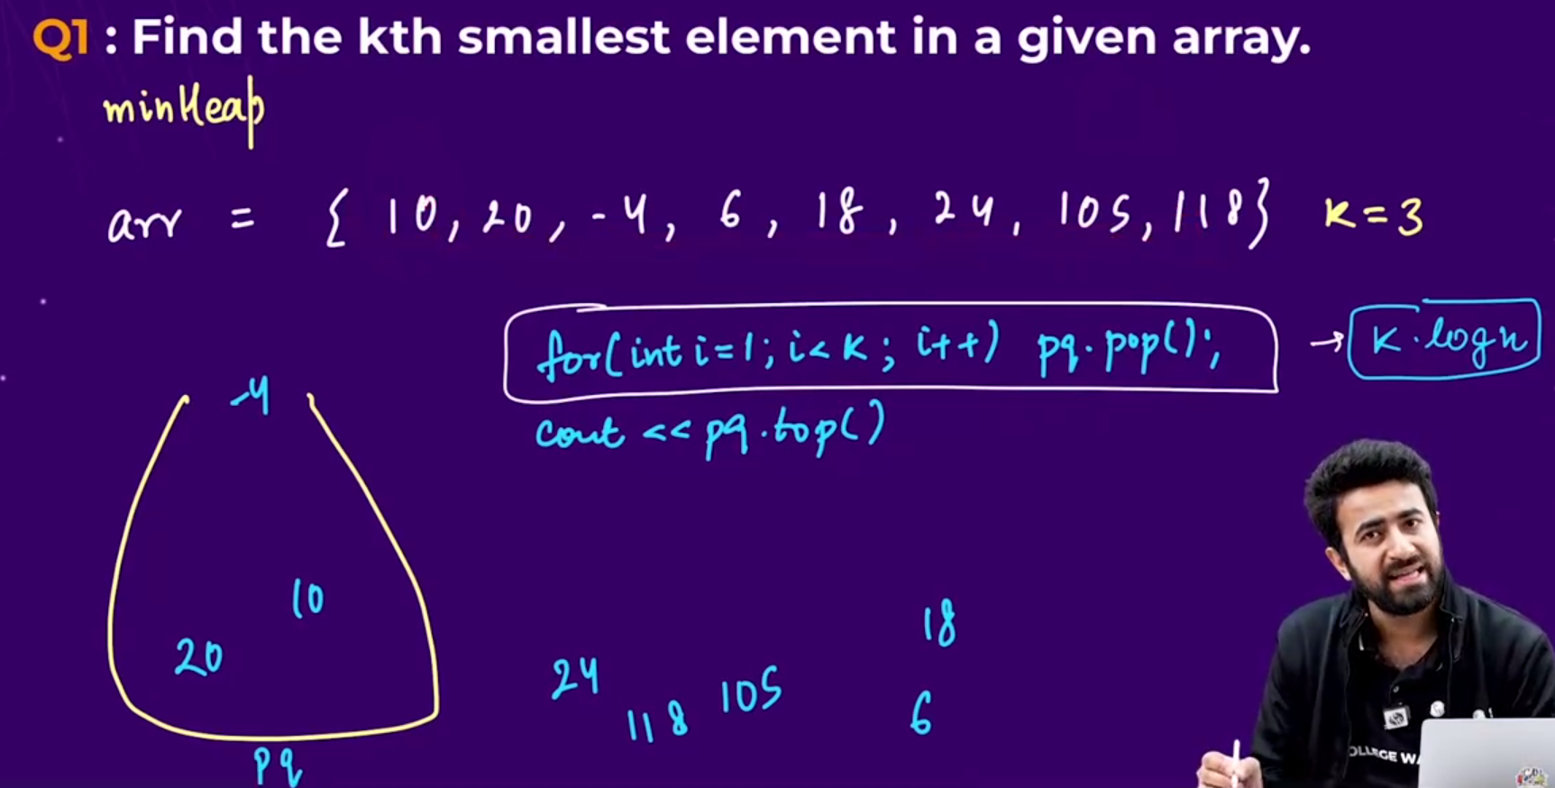

* + **Note🡪** 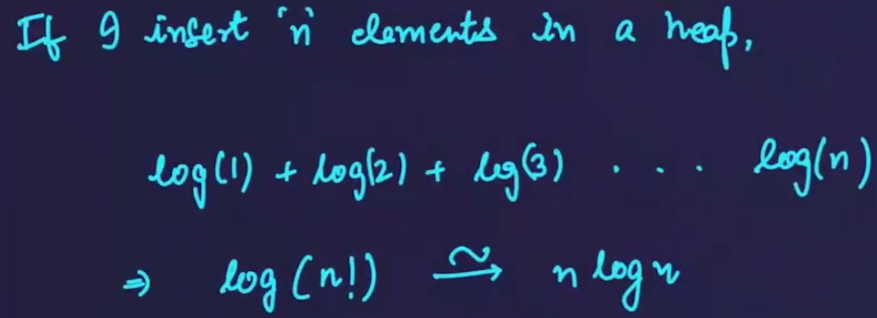
  + **Note🡪**
    - **In the question to find the kth smallest element in the array🡪use minheap**
    - **In the question to find the kth largest element in the array🡪use maxheap**
* Method 5🡪using maxheap
  + Algorithm🡪 form the maxHeap of size k , elements ko daalte jaoo in the heap and jaise ji heap ka size k se bada hoga tb last element ko pop kr do becoz who 3rd smallest element to nhi ho skta becoz usse 3 chhote elements neeche pare hue h in the heap so ,and jaise hi last m array ke elements khatm ho jaaye then return the top element of the heap.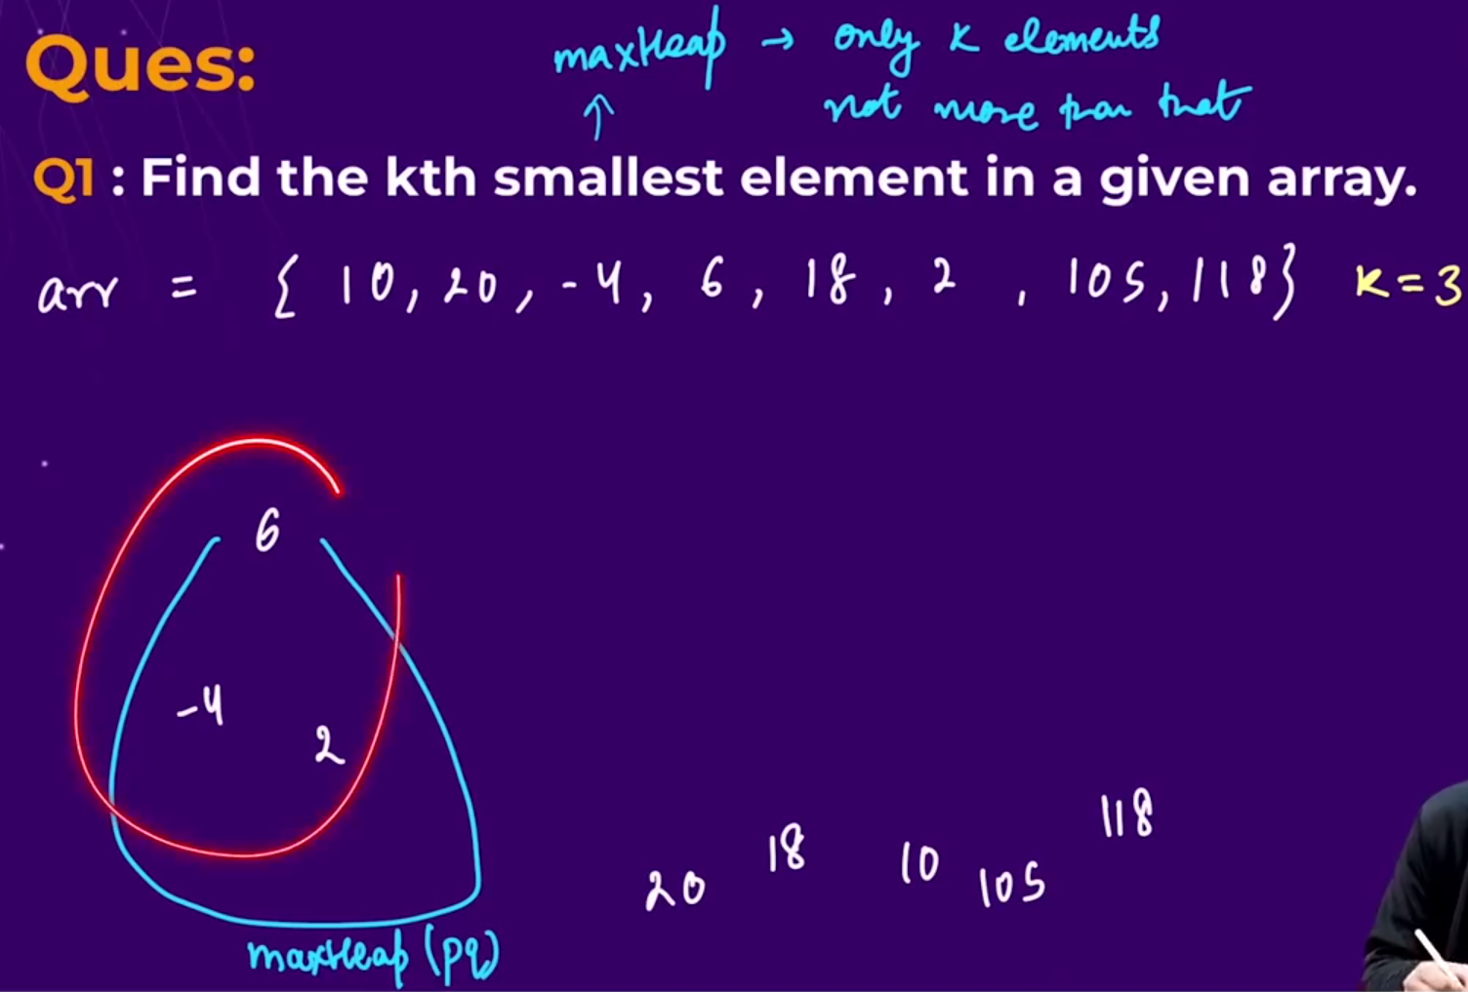
  + 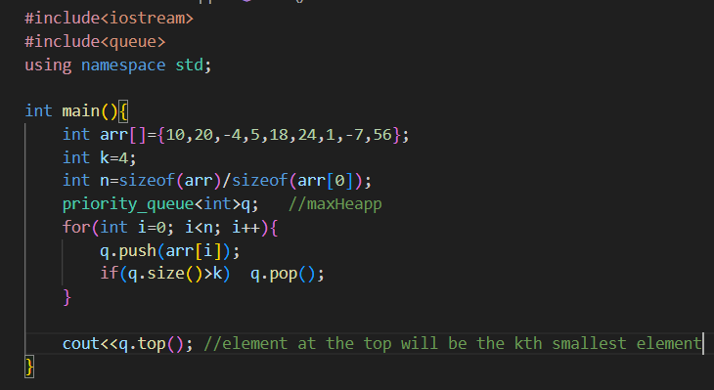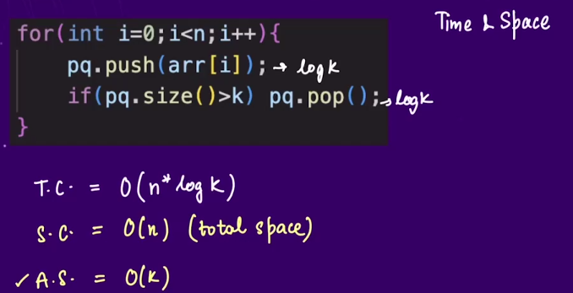-🡪time and space complexity of above algorithm,
  + Time complexity🡪 total elements of the array are being inserted in the heap so, **O(n)** and each time the elements are arranged internally to make the largest elemnt be at the top , so **O(log k),** so the total time complexity 🡺 **O(n logk)**
  + **Space complexity 🡪** total elements are being inserted in the heap , so space complexity = O(n)
  + **Auxilliary space complexity 🡪** space complexity at the end of the operation, 🡪 only k elements will be there in the heap , so the auxiliary space complexity will be 🡪 O(k).

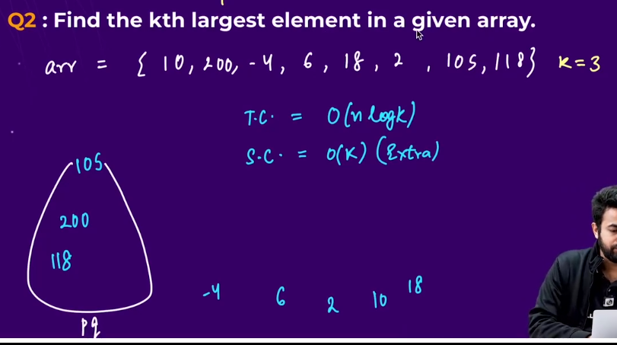**🡪 Logic is just opposite of above question.**

* **Create a minheap.** 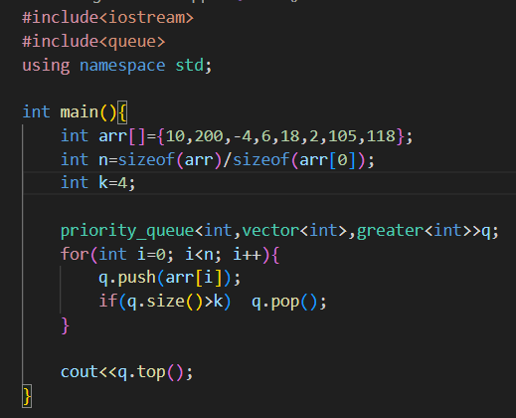
* 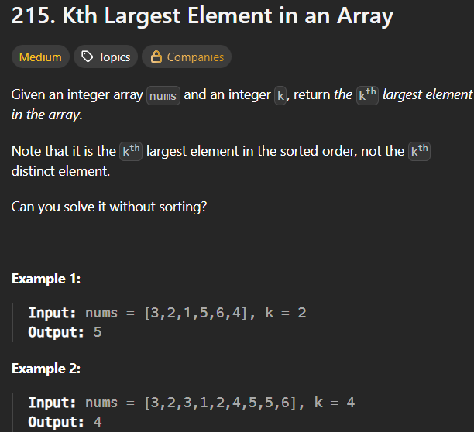**🡪same above question**
* **Method 1 🡪 using minheap**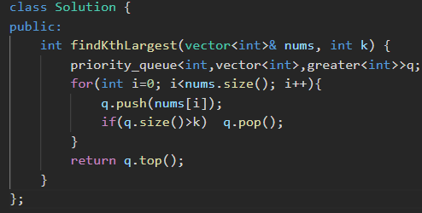
* **Method 2 🡪 using sorting** 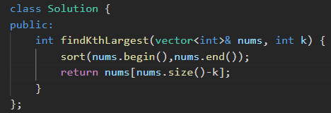

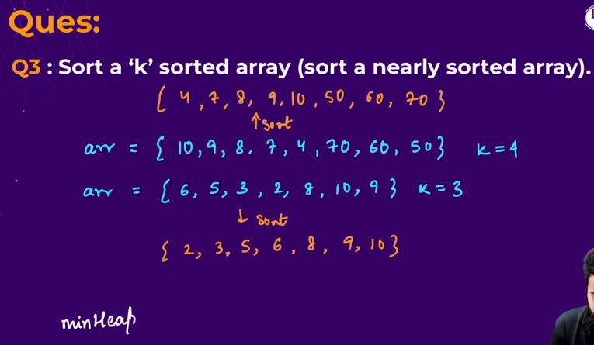**🡪** k sorted array means, koii bhi element apne index se bs , k index aage ya peeche ho skta h, usse jyada nhi, so hme iss k sorted array ko sort krna h.

* Algorithm 🡪 build a minheap, then usme pehle k elements daalo, and jaise hi minheap ka size k se bada ho jaayega, then, top element ko pop krte rho and answer array m usko push krte rho and at last answer array ko return krwa do.
* 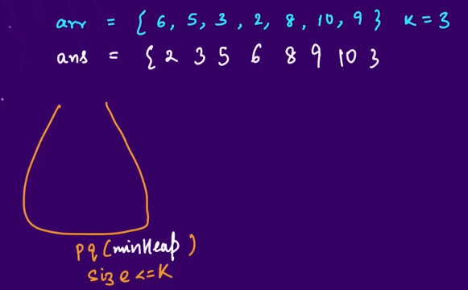
* 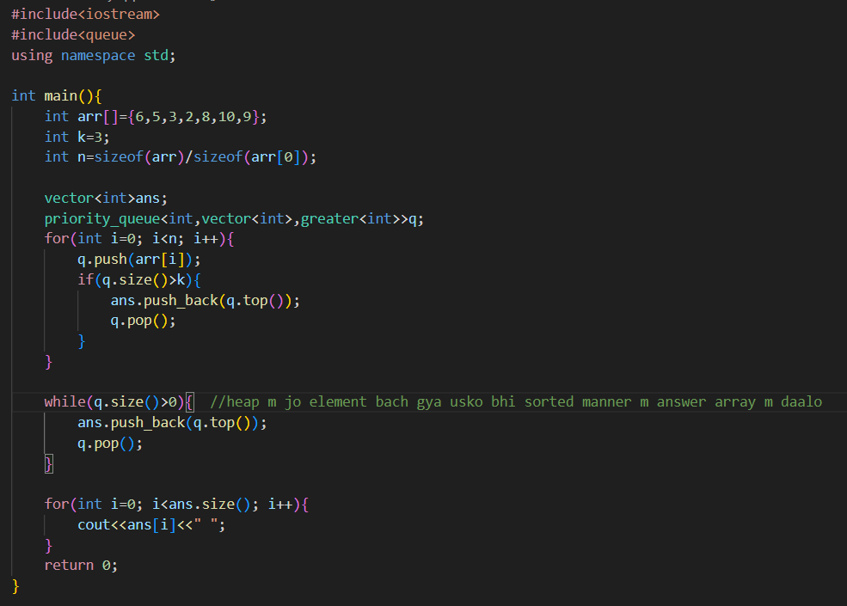

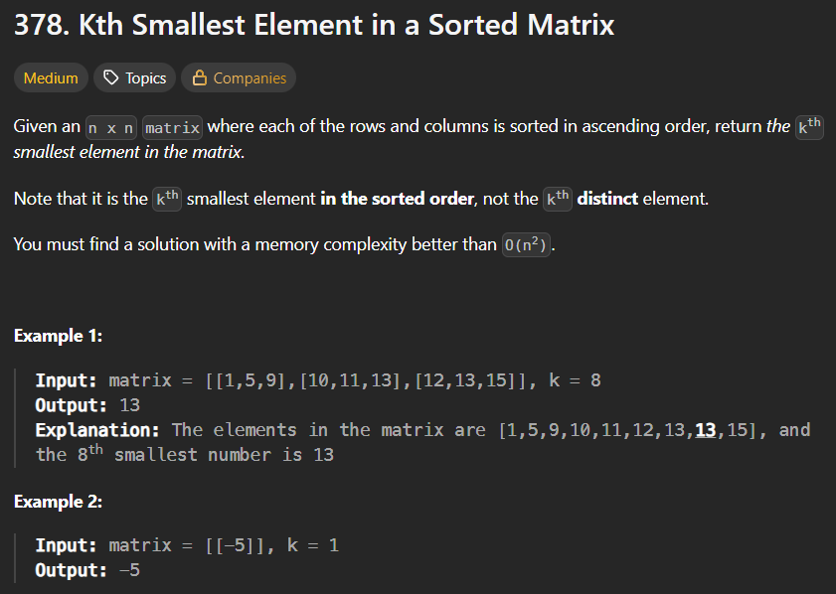**🡪similar to above question**

* Method 1🡪 using maxHeap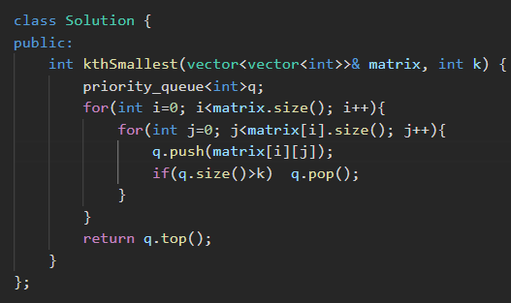

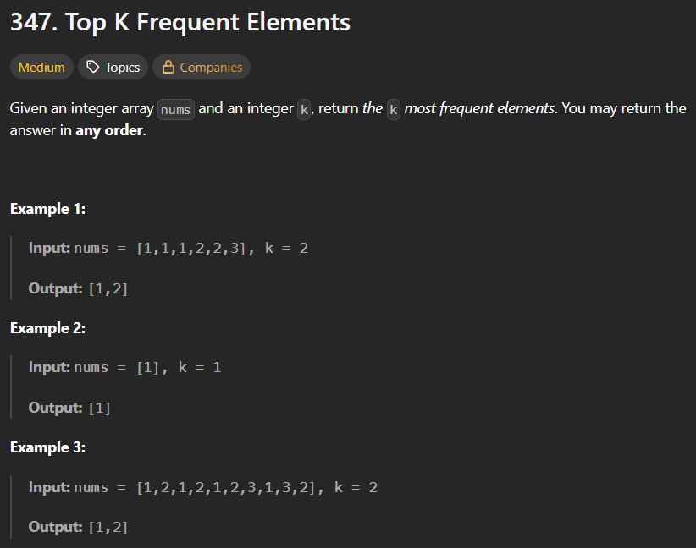

* Method 1🡪using maps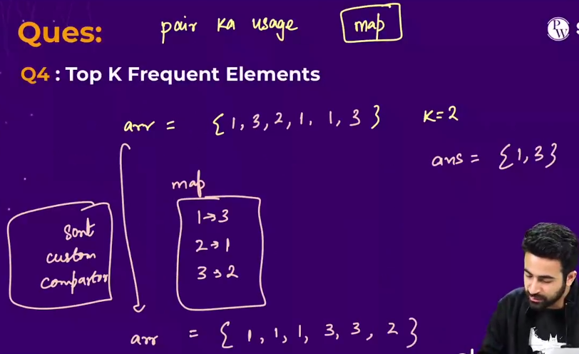
* Method 2🡪using heaps+heap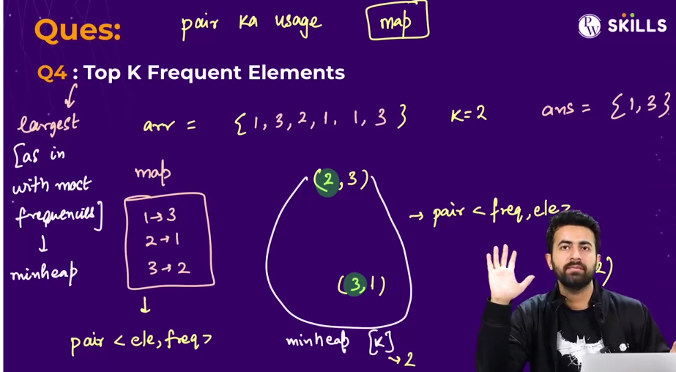🡪this question is same like **kth largest element**, only the difference is that ki iss question me hme pair ka use krna para. 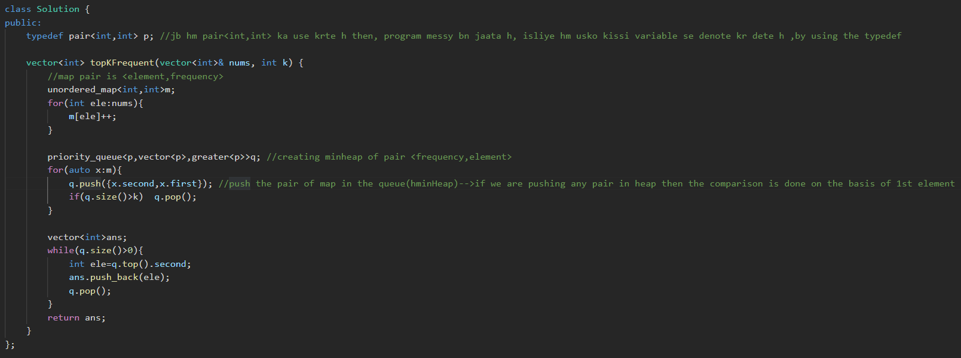

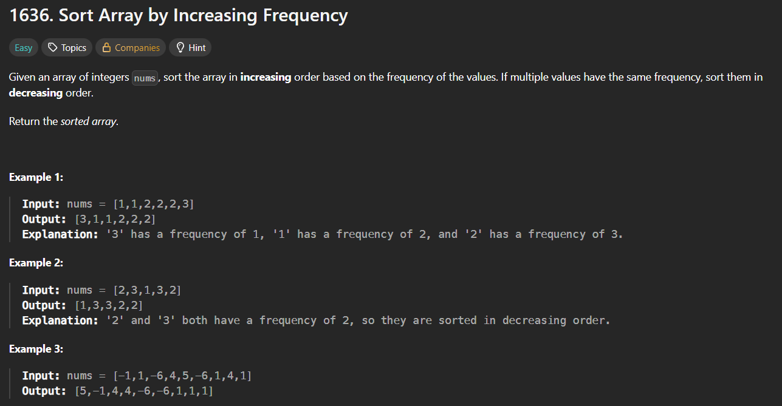

* 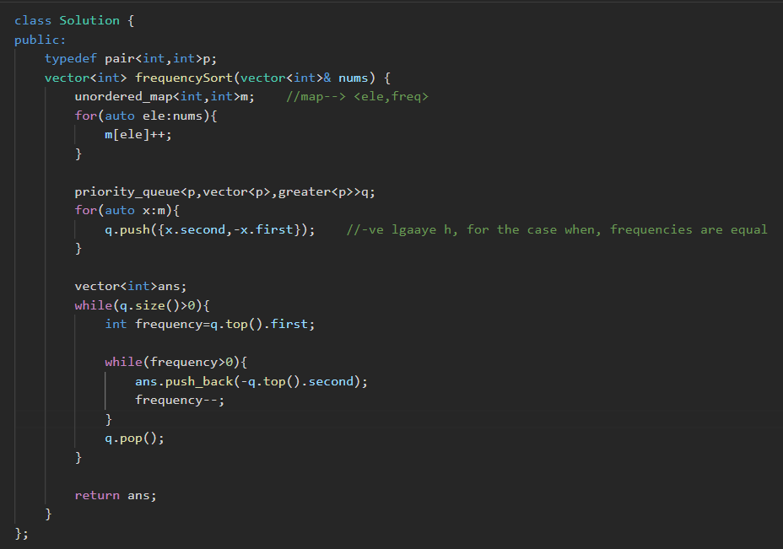

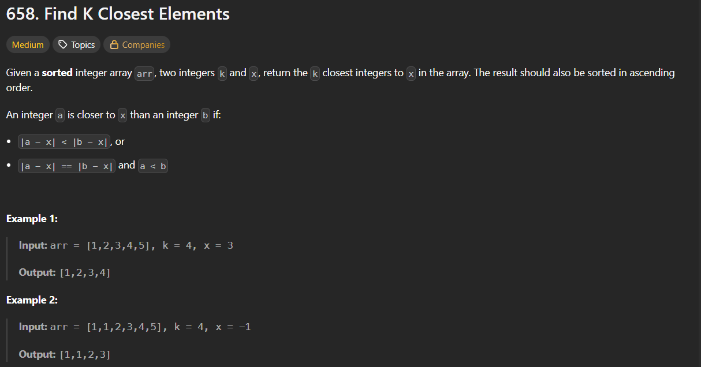

* Method 1🡪Binary search🡪see logic in C++ copy(prema public waala)

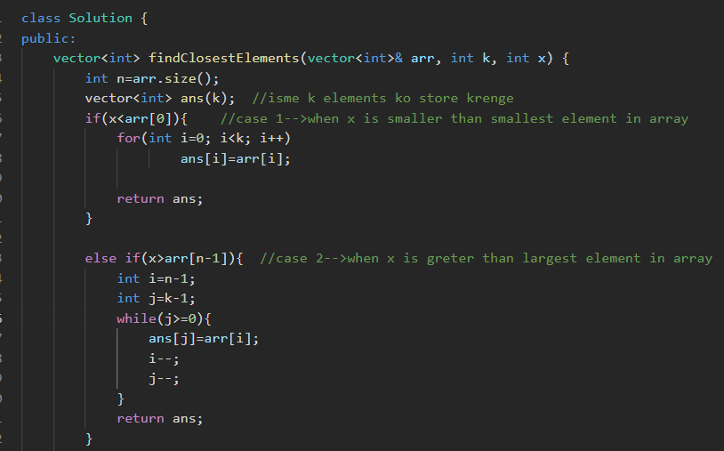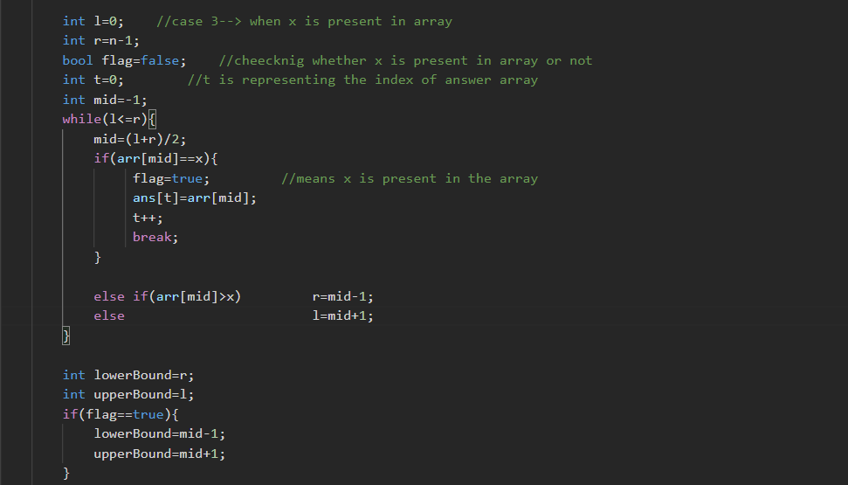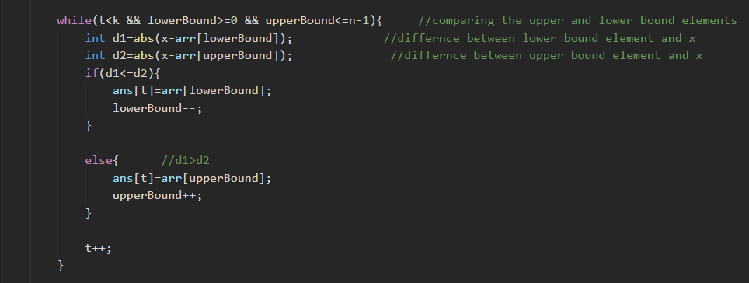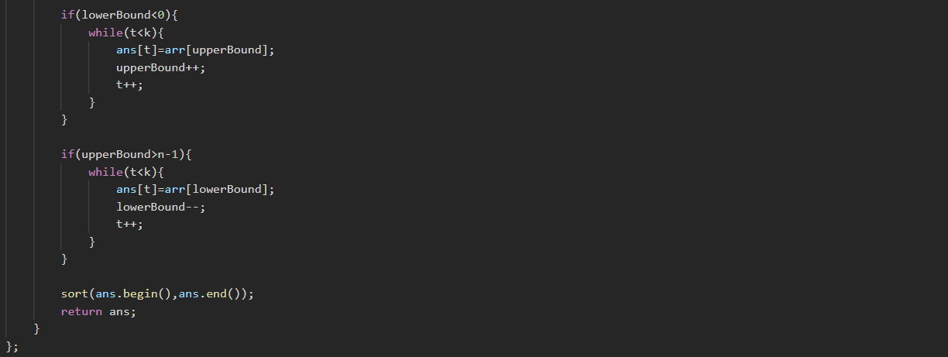

* Method 2🡪using heaps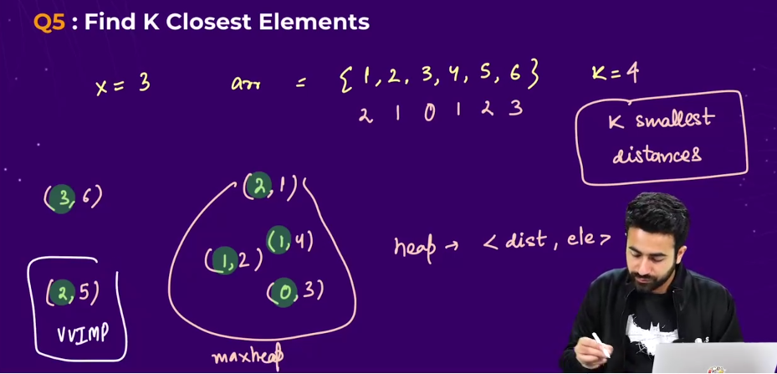-🡪Algorithm
  + Pehle ek loop chalaake on the array , distance calculate kr lo, baaki elements ka from the given element **x** , then har ek element ko with their distance maxheap m push krwaate jaao, in the format **<distance,element>**, then jiska distance jyada hoga woh element top p aa jaayega. And then jaise hi heap ka size **k** se jyada ho jaayega , elements ko pop krwaana start kr do.
  + **Note 🡪 very important** 🡪 jb koii aisa case aa jaaye when , uska distance equal h , i.e 1st element is same in two cases , then comparison inside the heap is done on the basis of 2nd element., so baad waala element pop ho jaayega (i.e what we needed in this question.)
  + 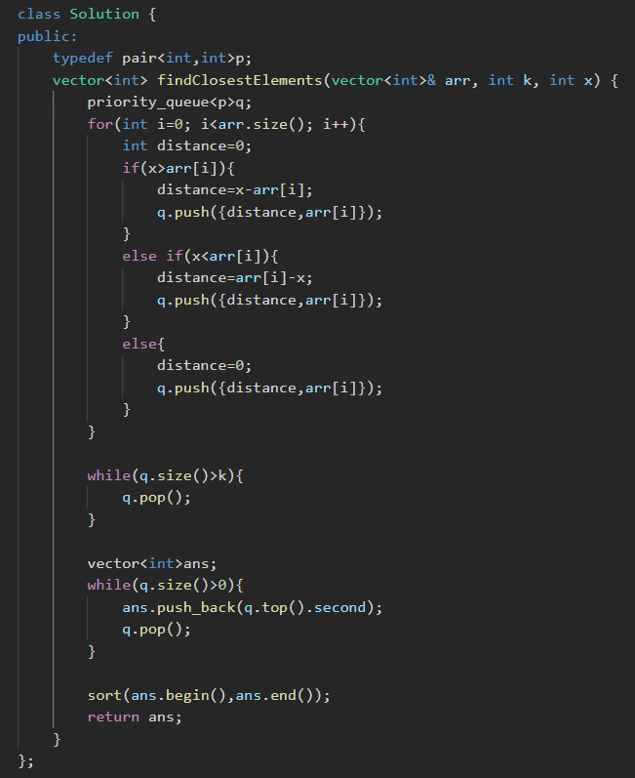
* Method 3🡪 above code in optimized manner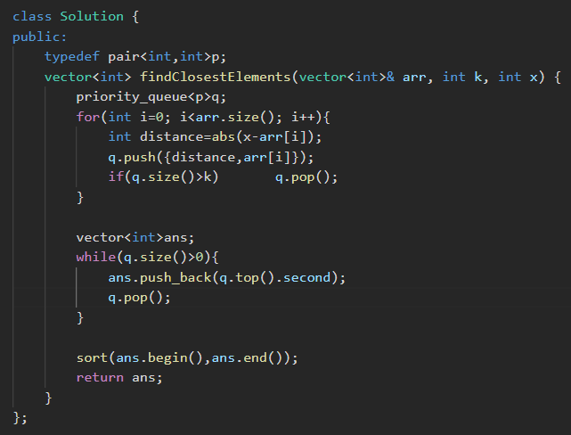

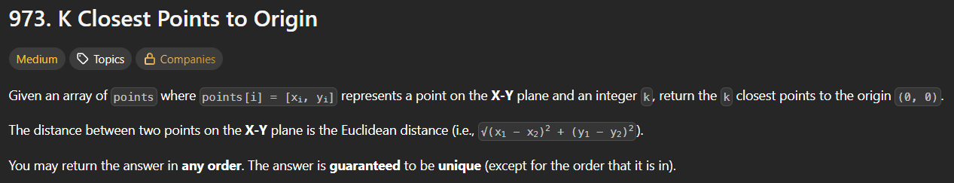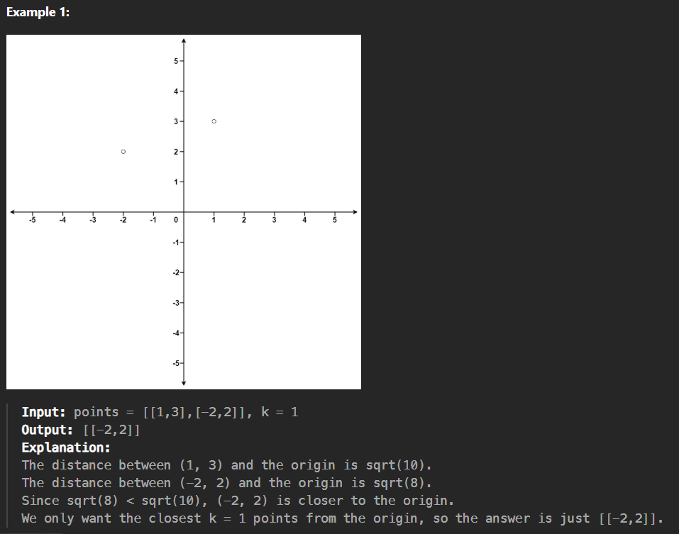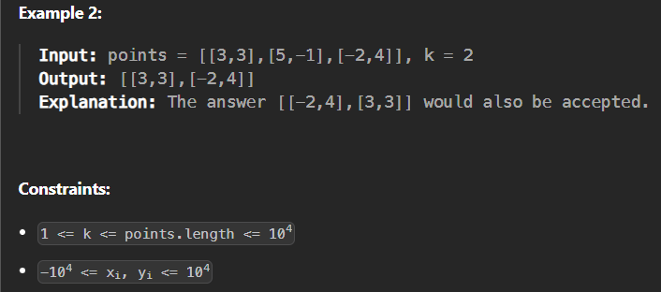

* Concept is similar to above question 🡪leetcode 658 🡪the only change is that , we have to calculate the distance from the origin.
* 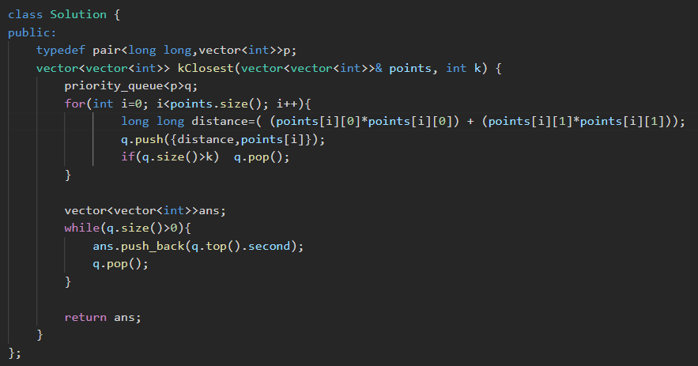
* Method 2🡪just written the above method code in simpler way, by using only int not, long long

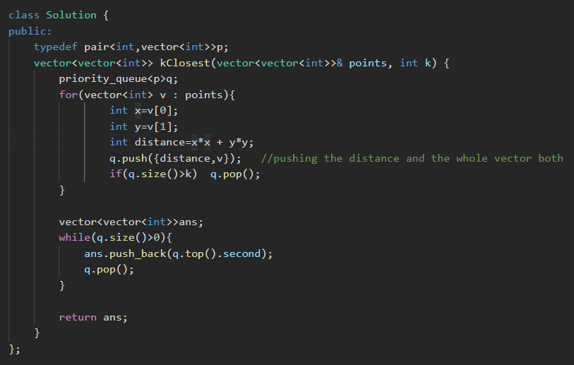

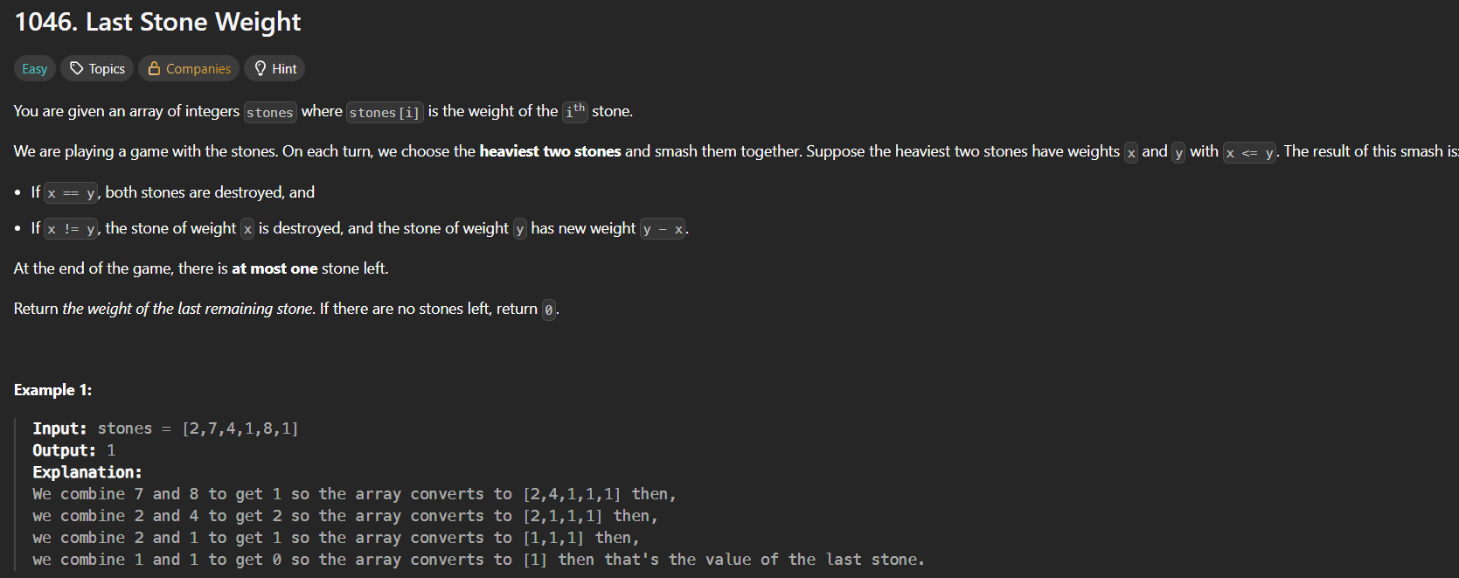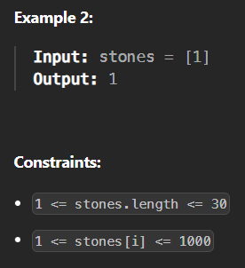

* Method 1🡪my method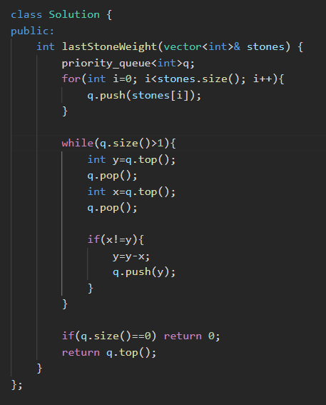
* Method 2🡪sir’s method🡪same an my method, only written in another way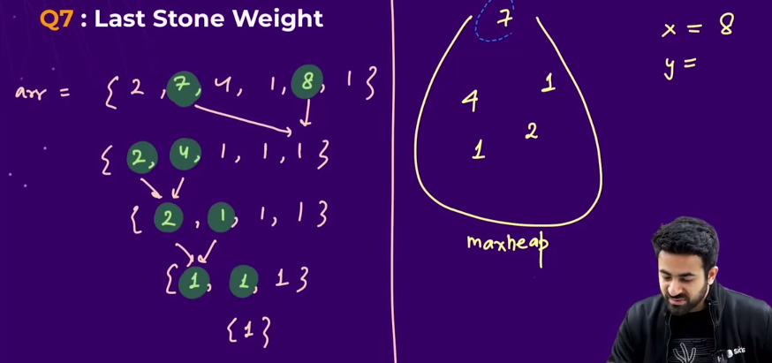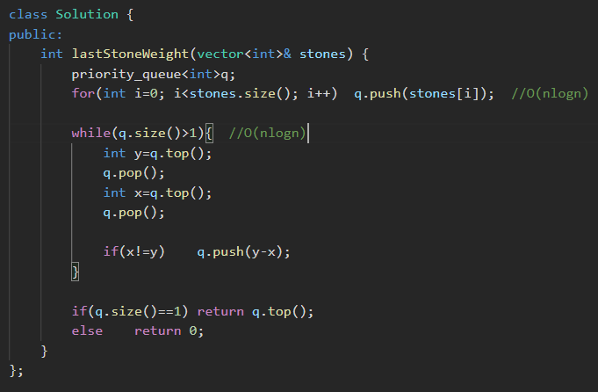
* Method 3🡪using sorting and vectors🡪O(nlogn) after every iteration in sorting, therefore this has a bad time complexity , 🡪 better approach🡪heaps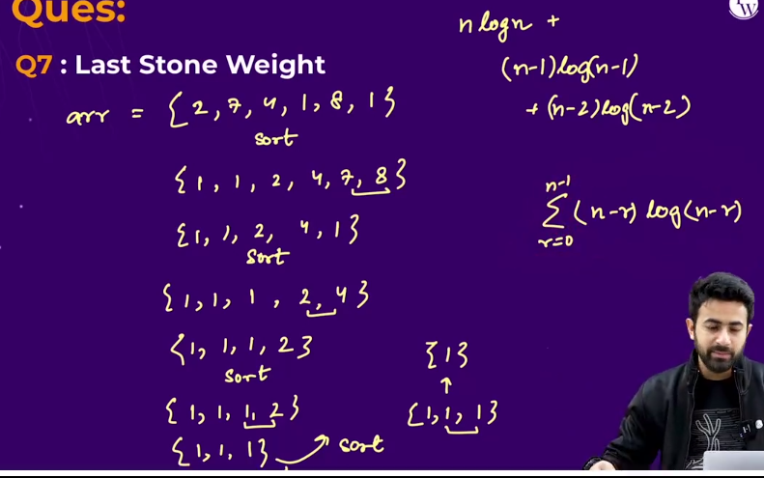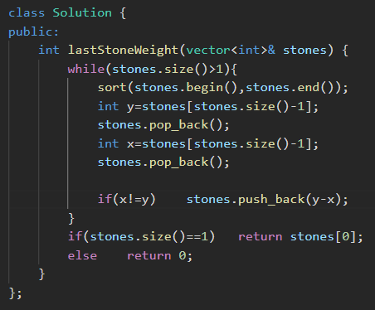

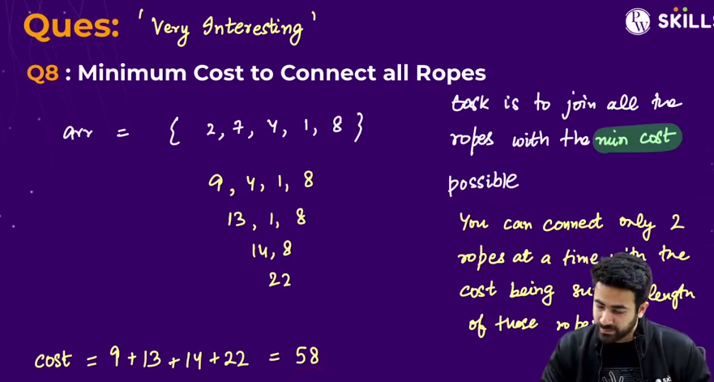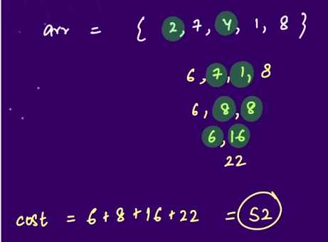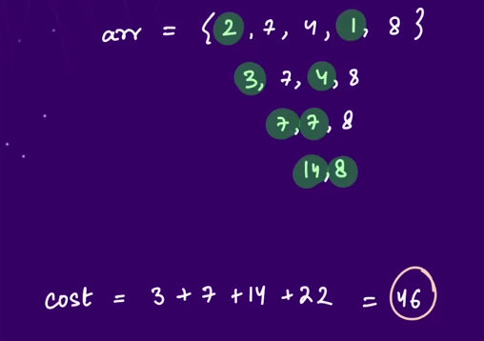🡪 GFG question

* Algorithm🡪select the 2 smallest element at each time so that the cost will remain the least.

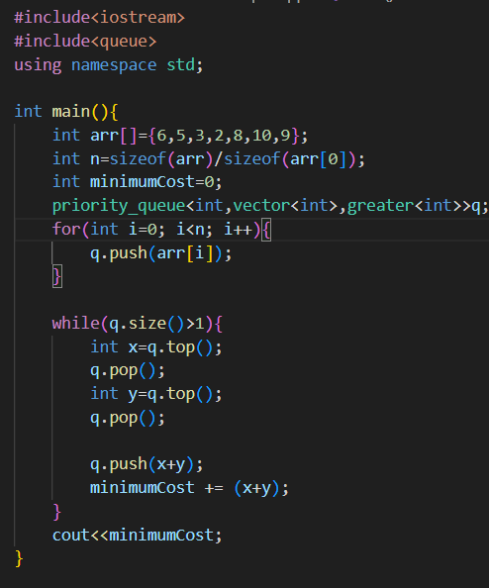



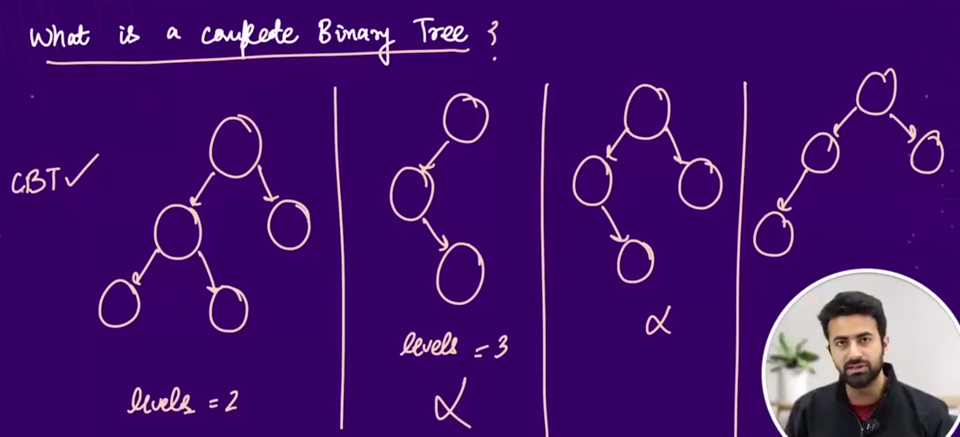

* Properties of a complete binary tree:
  + Top to down jaate waqt left to right filling hona chahiye
  + And last level ko chor k upar k saare levels filled hone chahiye.

till now we have visualized the heap like this.

* 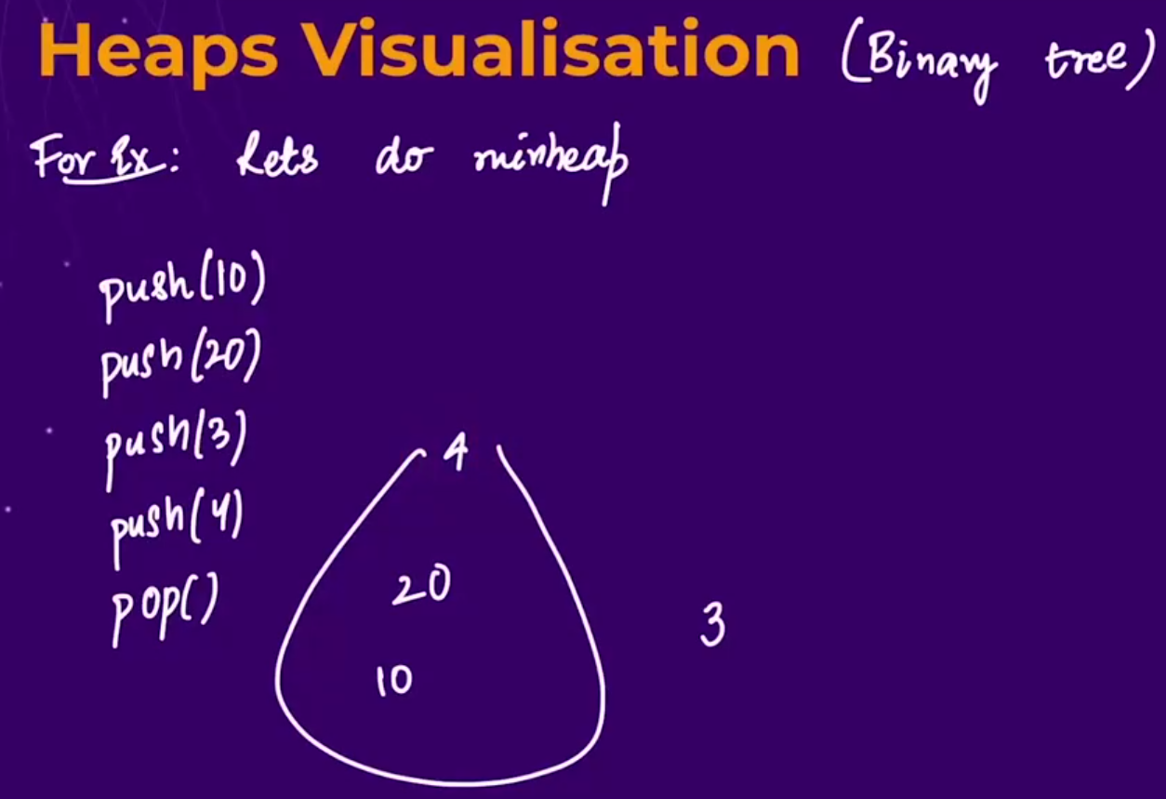

Now visualizing the heap as a tree:

* 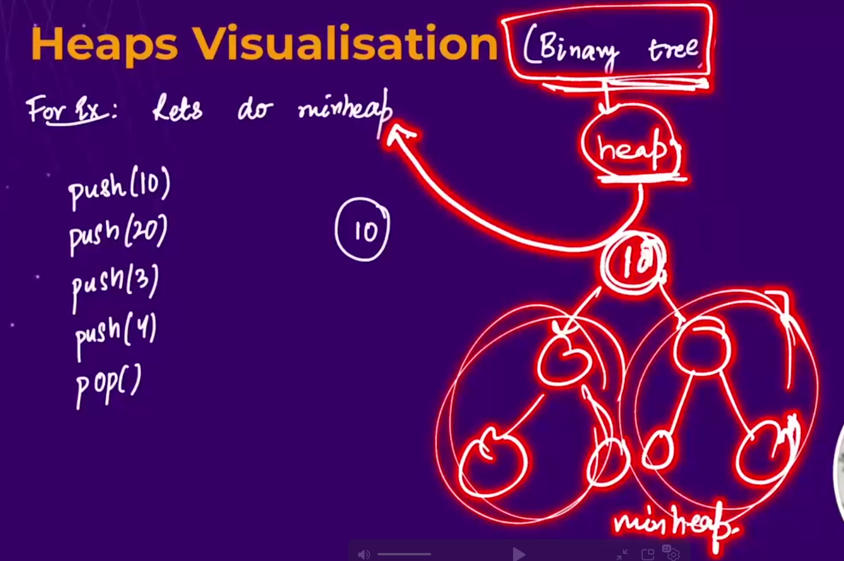
  + Note : the difference between the heap and binary search tree is that,
    - in the heap(in tree format) both the left subtree and the right subtree below a particular node are smaller than the root node(in case of maxheap) and larger than the root node in case of minheap
    - but in the binary search tree the left subtree is smaller and the right subtree is larger than the root node.
    - Iska mtlbb h ki , in heap for a node , uske left subtree and right subtree m kya h usse koii mtlbb nhi, bs root node neeche waalo se bada hone chahiye in case of maxheap and Chhota hona chahiye in case of minheap.
  + Eg: 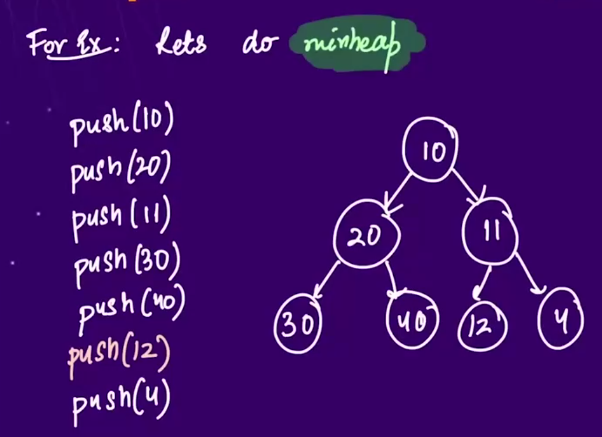🡪 swap 4 and 11 , becoz it is a minheap and upr Chhota element hona chahiye.

🡪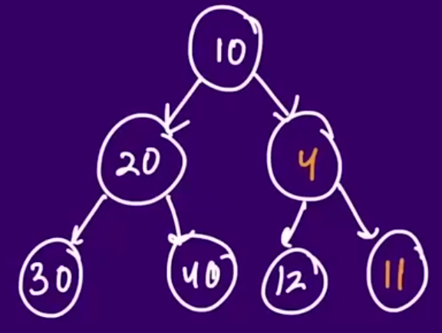🡪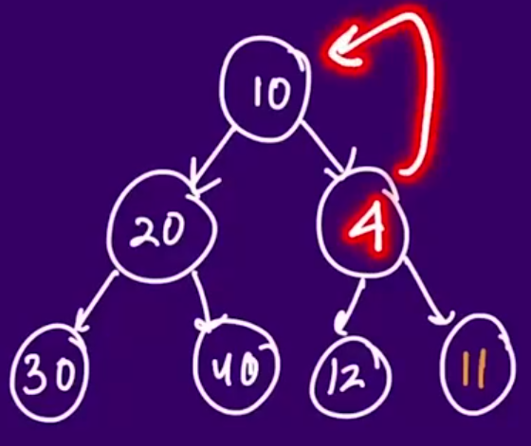🡪

🡪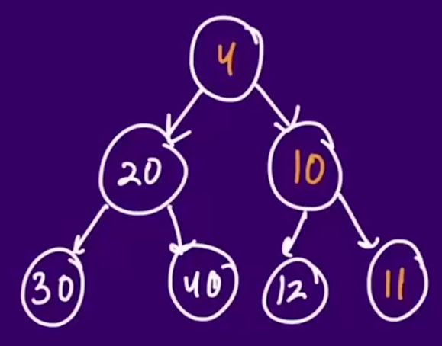🡪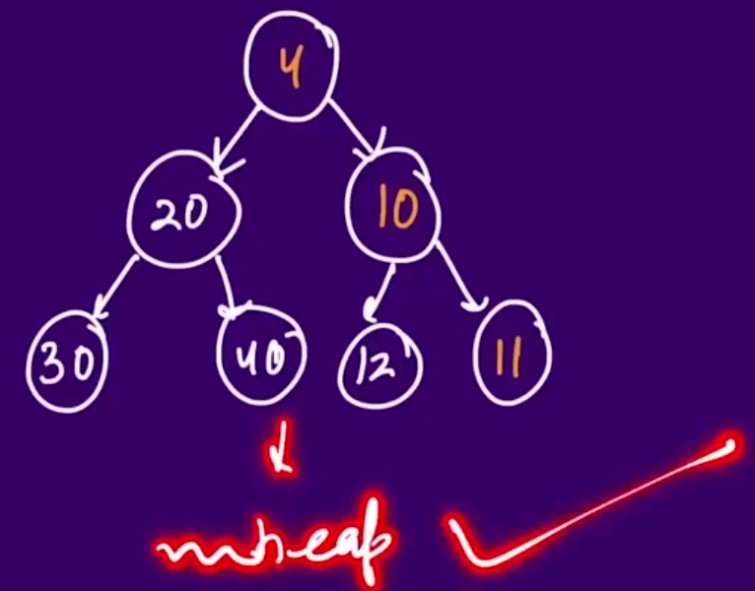

* 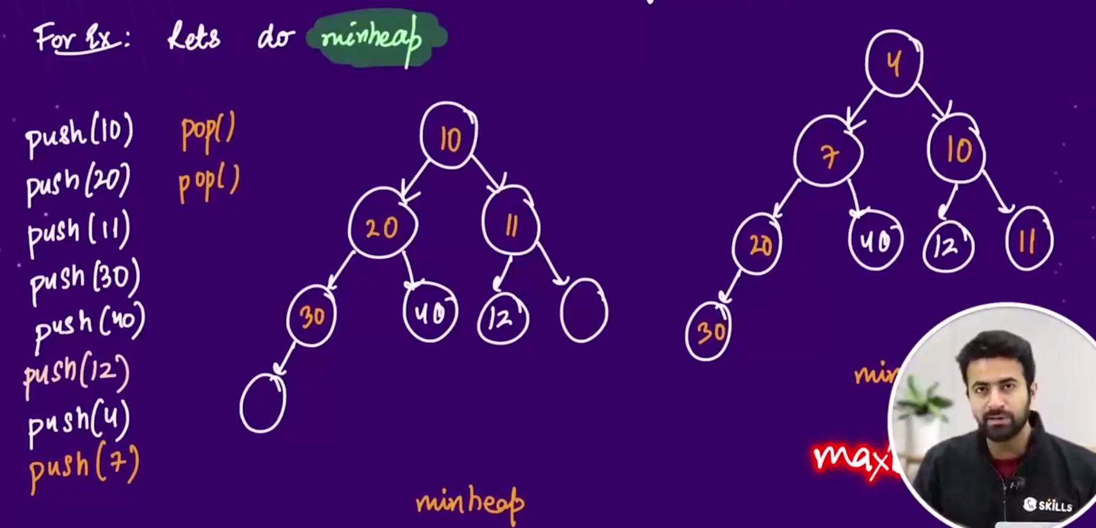
* 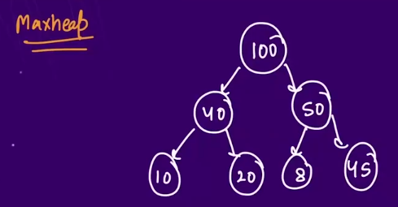

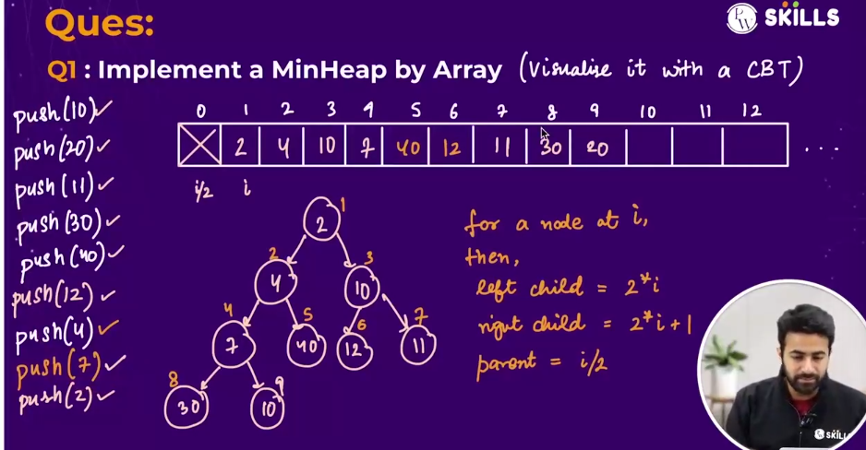

* To implement the minheap using array—
  + 1st point to be noted🡪 minheap m root k neeche jitne bhi elemnets hote who root se bade hote h.
  + In a minheap, for any node i ,
    - Left child = 2*i
    - Right child = 2*i + 1
    - Parent = i/2
  + **To implement the push operation minheap using array:** , elements ko array m daalte jaoo, and uska parent(at i/2) k index p check krlo ki who element current element se bada h ya nhi , and if bada hua to current index ko i/2 p shift kro, and then phir se i/2 p jaoo and check the same thing , and lastly jb parent node bada ho jaaye ya hm 0th index(jaha koii bhi element nhi h) p pahuch jaaye then, loop ko terminate kr do.
  + **To implement the push operation minheap using array:** 1st element(index 1 p jo h usko htaoo) ko pop kro, then, index variable ko ek peeche lekar jaoo and uspe jo element present h , usko index=1 p lekar jaoo, and now uss element ko uske shi position p lekar jaoo, by comparing it with its left and right child.

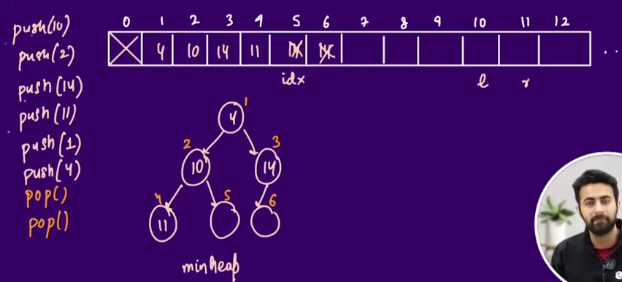

* 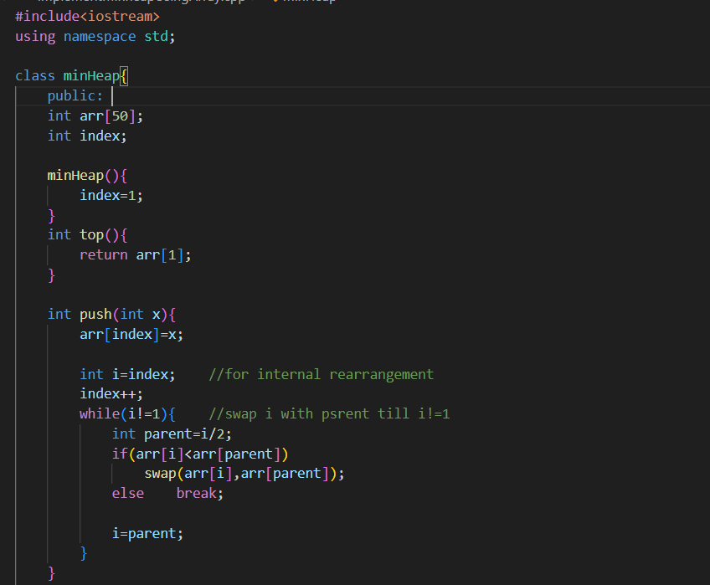 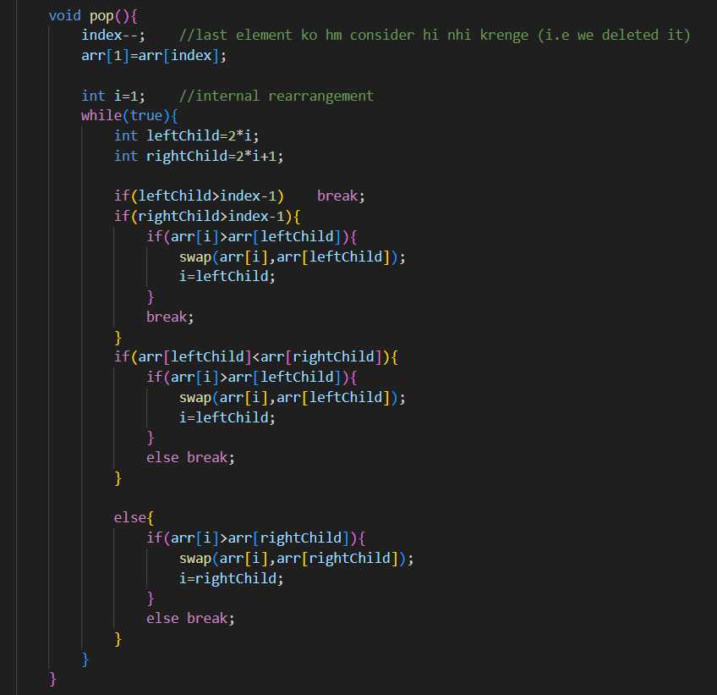 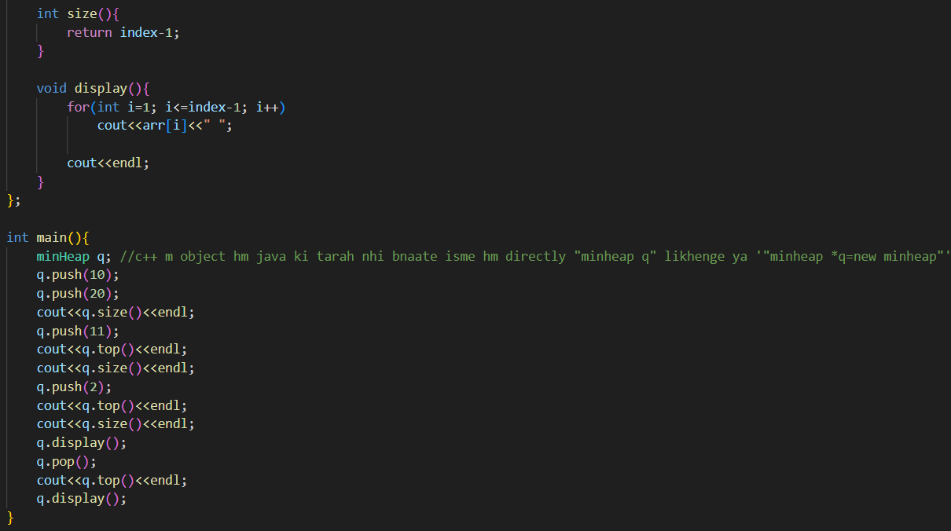

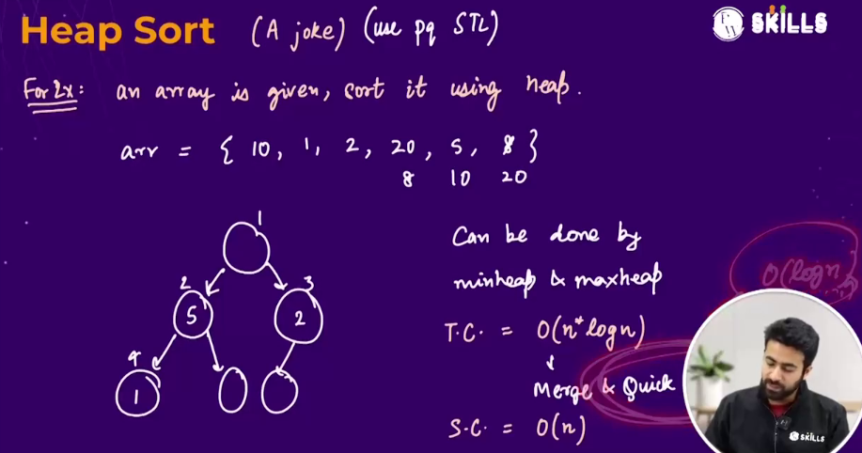

* Heap sort 🡪time complexity🡪O(nlogn)
* Heap sort can be done by both , maxheap and minheap 🡪 **Interview asked🡪 Rahul Sir**

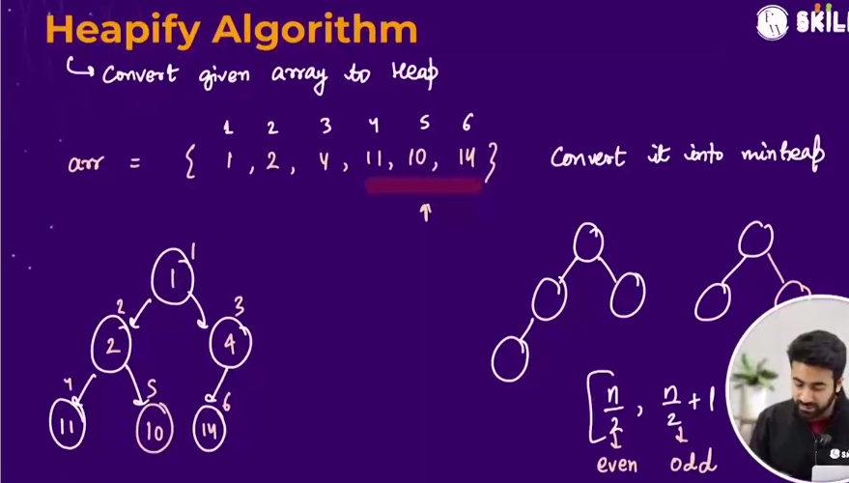

* Heapify ka mtlbb hota h ki, kissi array ko heap k form m convert krna , I.e, for a single node, neeche k saare elements usse bade honge (in case of minheap and vice versa in maxheap)🡪 we can do so , just by checking the internal nodes (nodes except the leaf nodes).
* No. of leaf nodes in a complete binary tree:
  + In case of even no. of nodes 🡪 n/2
  + In case of odd no. of nodes 🡪 n/2 +1
* 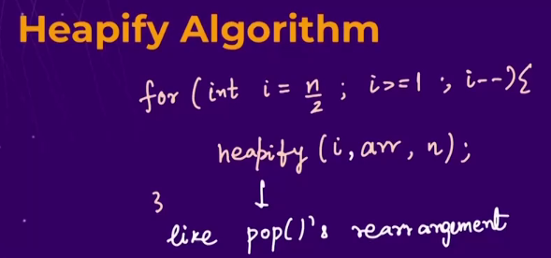
* 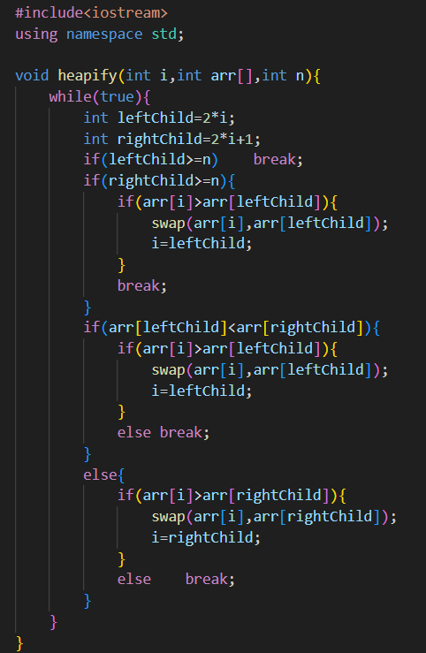

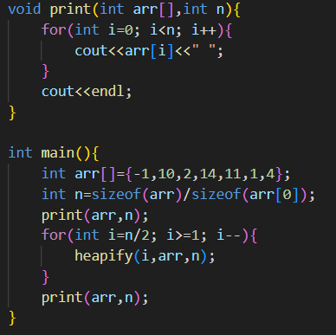

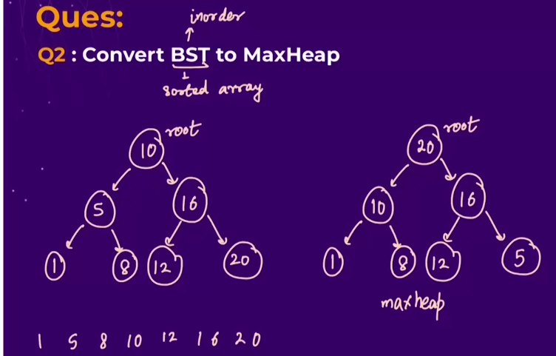

* 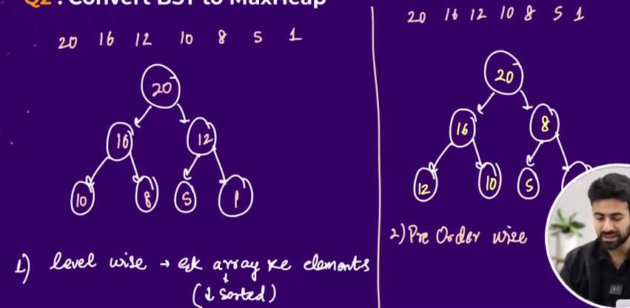
  + Method 1 🡪elements ko vector m daal k descending order m sort kr lo and tree m level order traversal wise elements ko daalte jaao 🡪 formed tree will be Maxheap
  + Method 2 🡪
    - elements ko vector m daal k descending order m sort kr lo and tree m pre order traversal wise elements ko daalte jaao 🡪 formed tree will be Maxheap and
    - elements ko vector m daal k ascending order m sort kr lo tree m inorder traversal wise elements ko daalte jaao 🡪 formed tree will be Minheap
    - 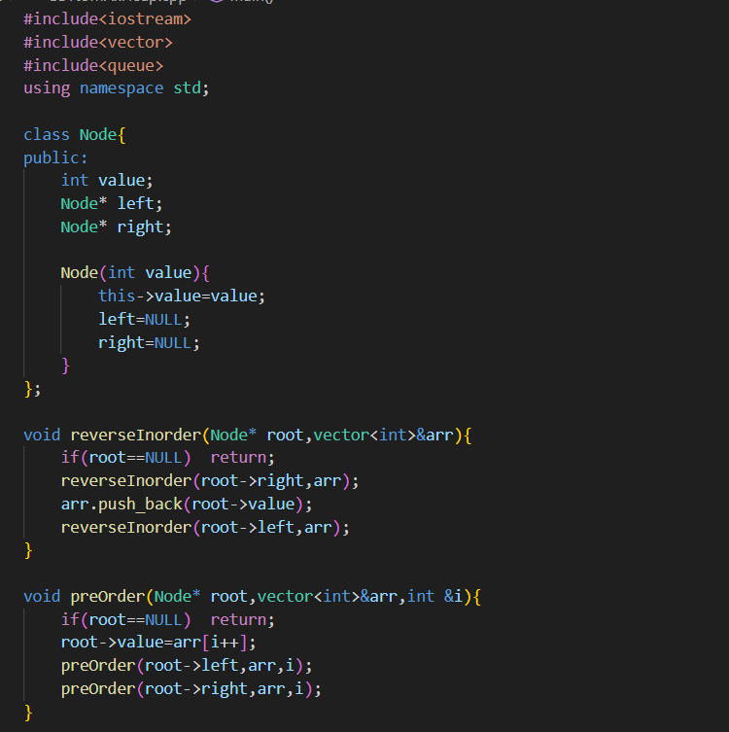 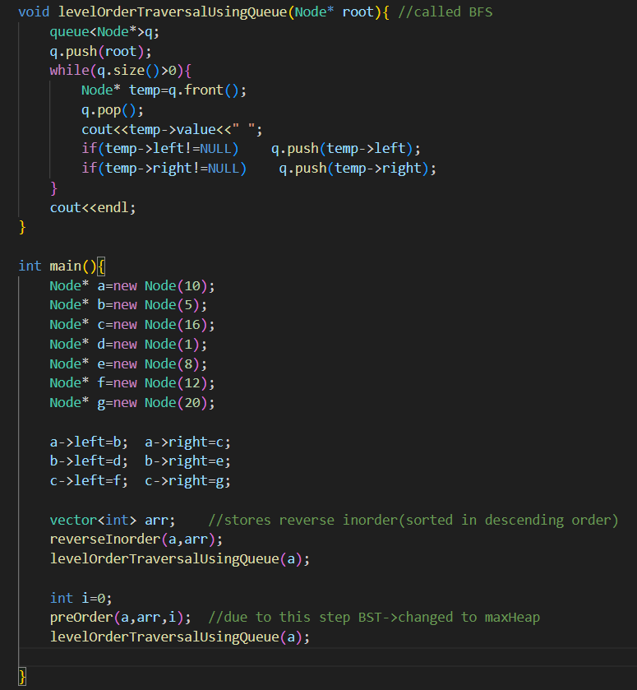

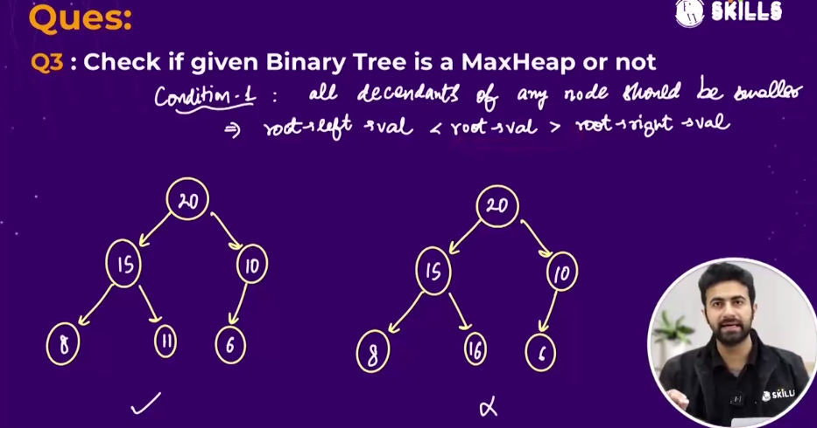

* 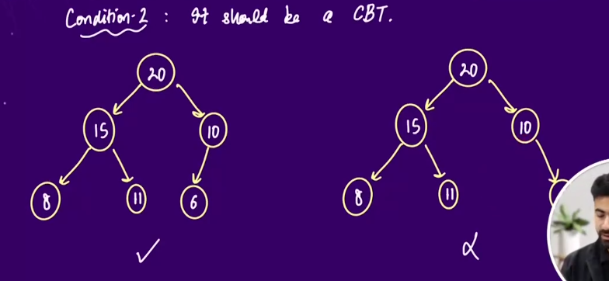
  + CBT🡪Complete binary tree
* Algorithm 🡪2 function bnaoo:
  + 1st to check that if the tree is complete binary tree(CBT) or not. 🡪 ek queue bnaao and saare elements ko queue m levelOrderTraversal wise bharte jaoo (all elements +NULL) , but jab hm NULL ko pop() krenge then check kr lenge ki queue m koii bhi aisa element h jo NULL nhi, agar nhi hua then, the tree I a complete biary tree and if hua then, it is not a complete binary tree.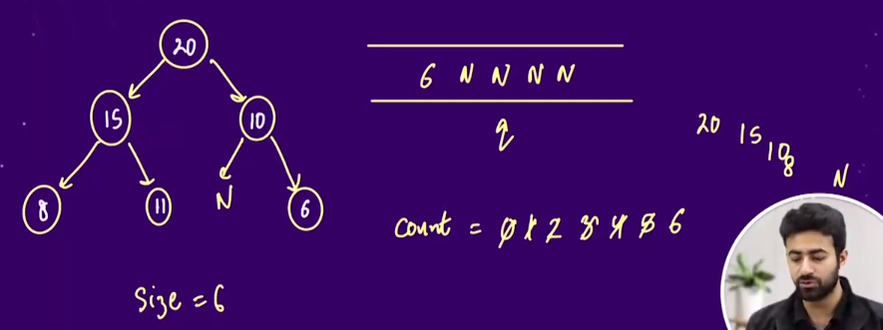
  + 2nd to check whether the below nodes(children nodes) are greater than the root node.
  + 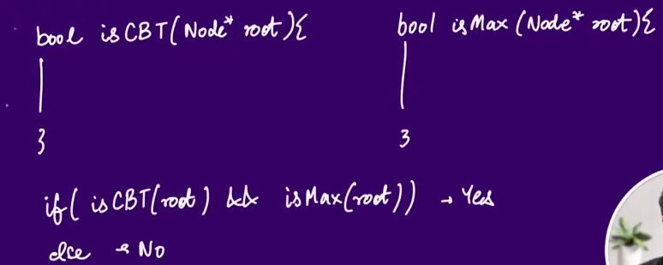
  + 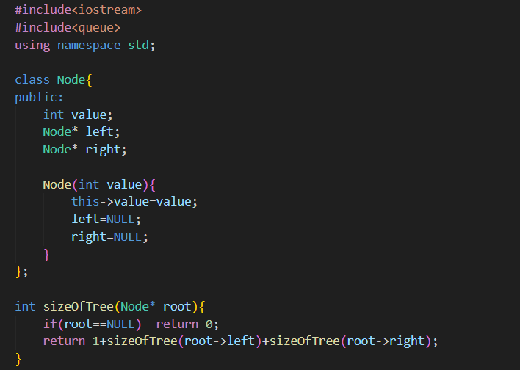 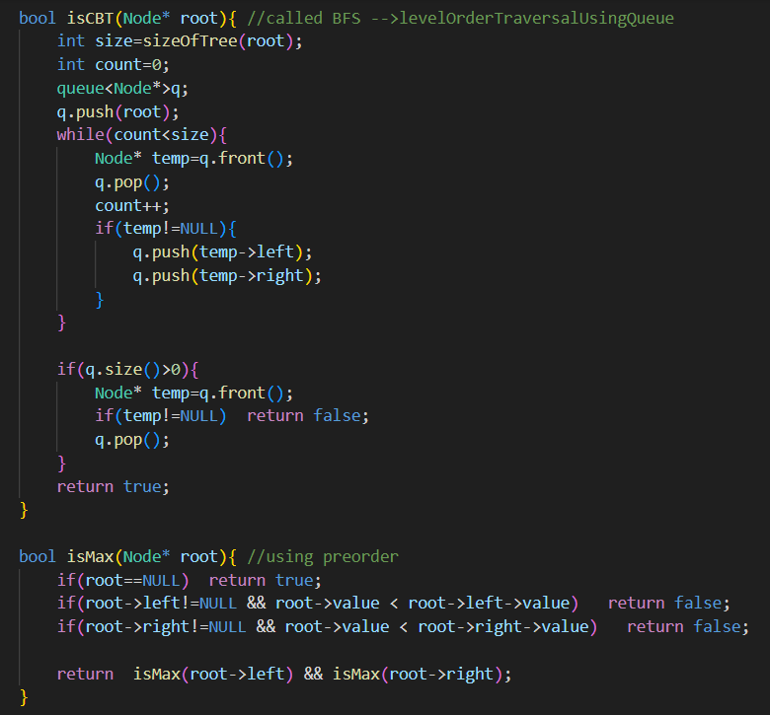 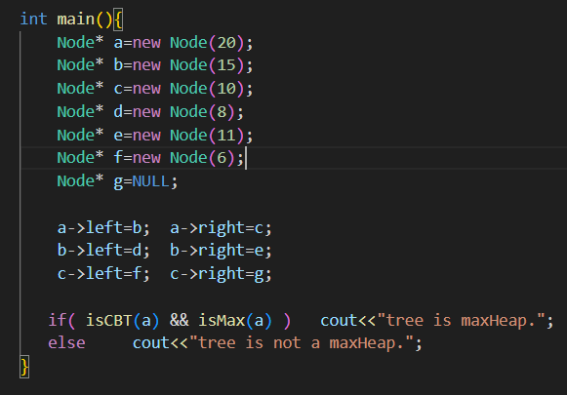 

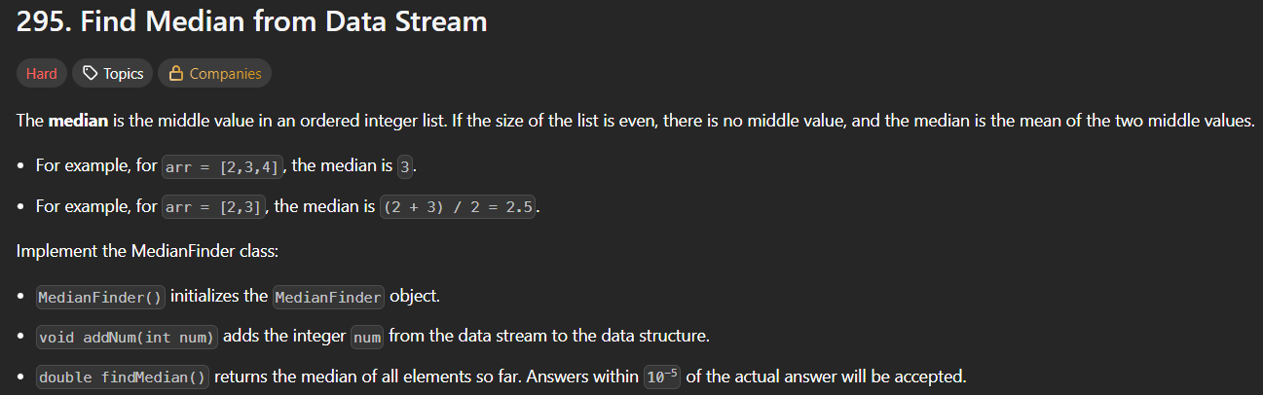 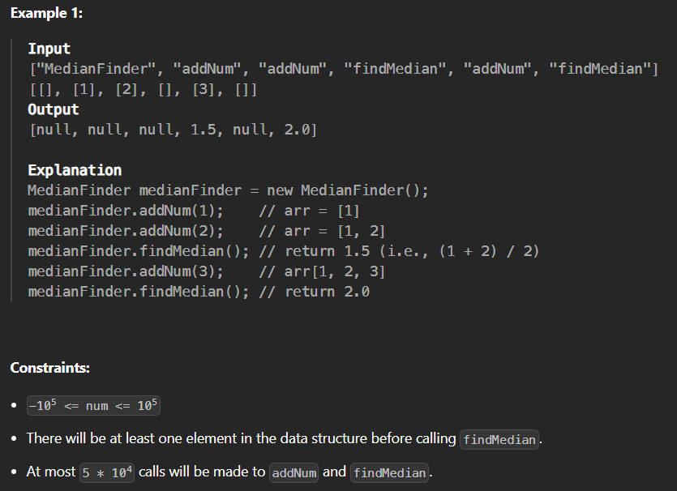

* 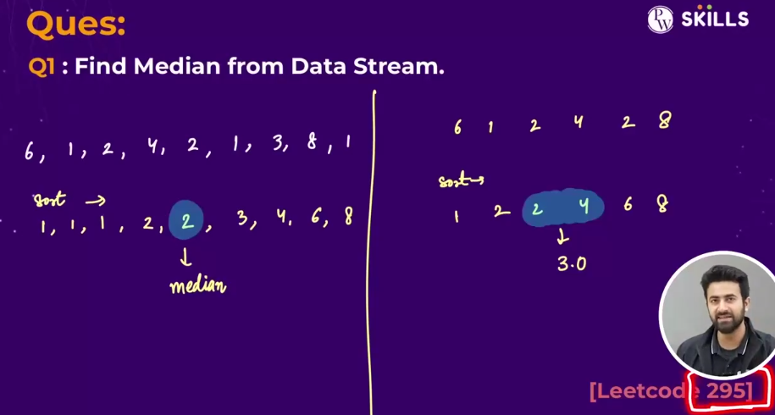
* 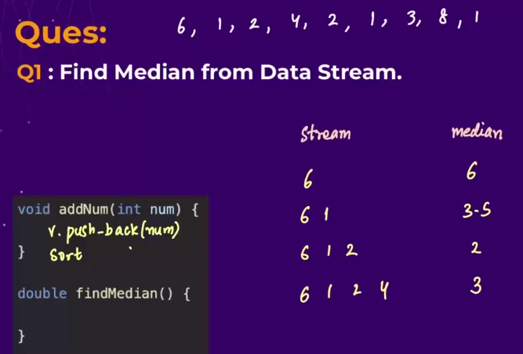🡪iss question ka mtlbb h ki hme ek ek krke elements milte jaayenge and and at every point of time hme median nikaalne k liye bola jaa skta h
* Method 1 🡪shows time limit exceeded 🡪becoz here sorting takes o(nlogn) everytime🡪becoz of quick sort(built in sort). 🡪 so as a result total time gets increased.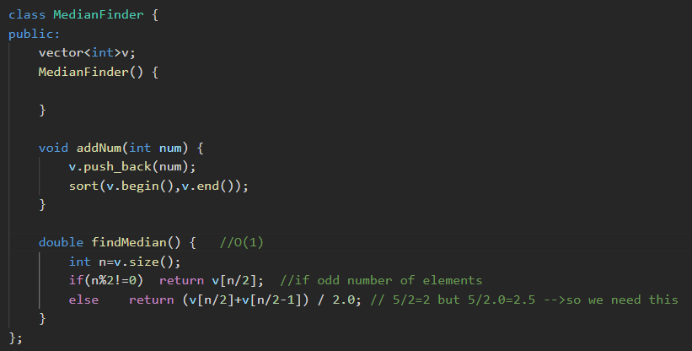
* Method 2🡪 using insertion sort for sorting 🡪 shows time limit exceeded 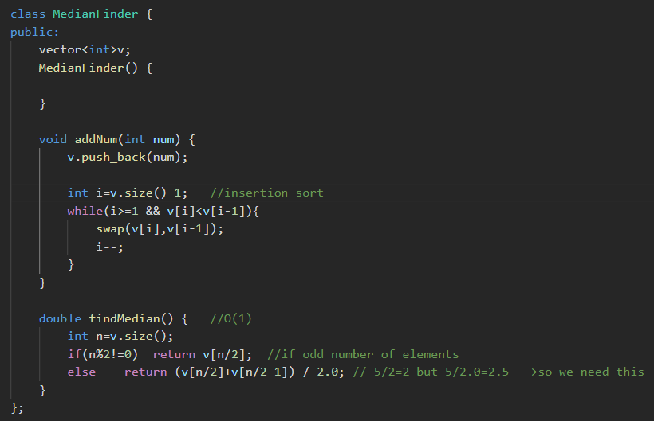
* Method 3🡪using maxheap and minheap🡪algorithm 🡪ek maxheap bnaaoo and ek minheap bnaoo, and aadha aadha elemnts dono m daal do, and then **avg of max element from the minheap and minelemnt from the maxheap will be the meadin.**

**And if the size of array is odd , then jisme jyada elemnt hoga ussi ka top element will be the median of the given data stream.** 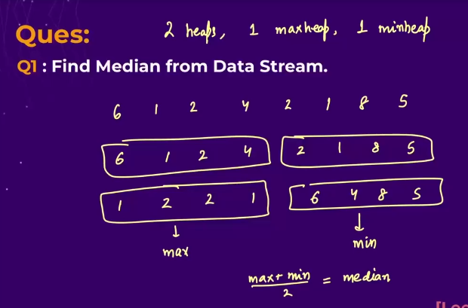

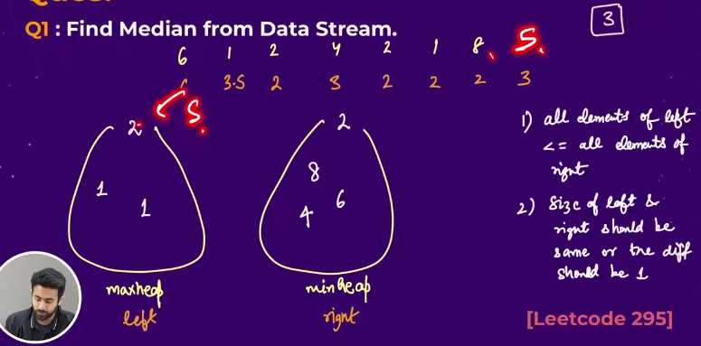🡪pehle 1st element daal in the maxheap and then to add further elements in the heaps, check ki coming elemnt current element se bada h ya nhi, if bada hua then maxheap m daal denge, and Chhota hua to minheap m . 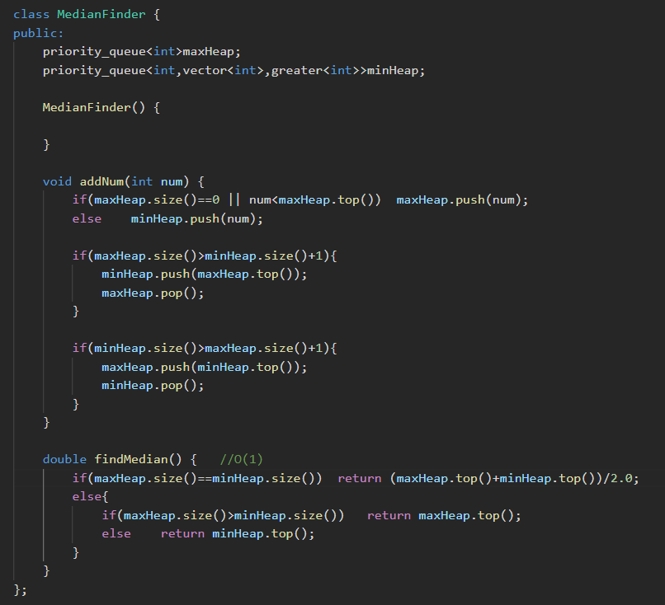

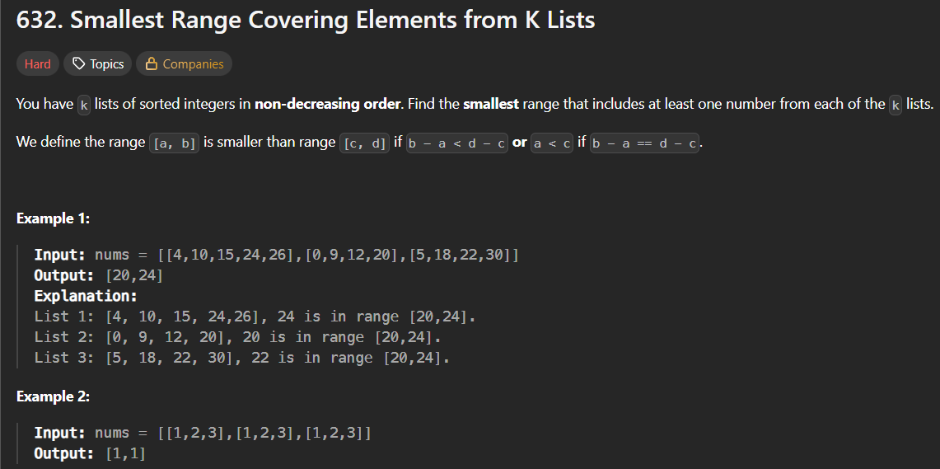

* 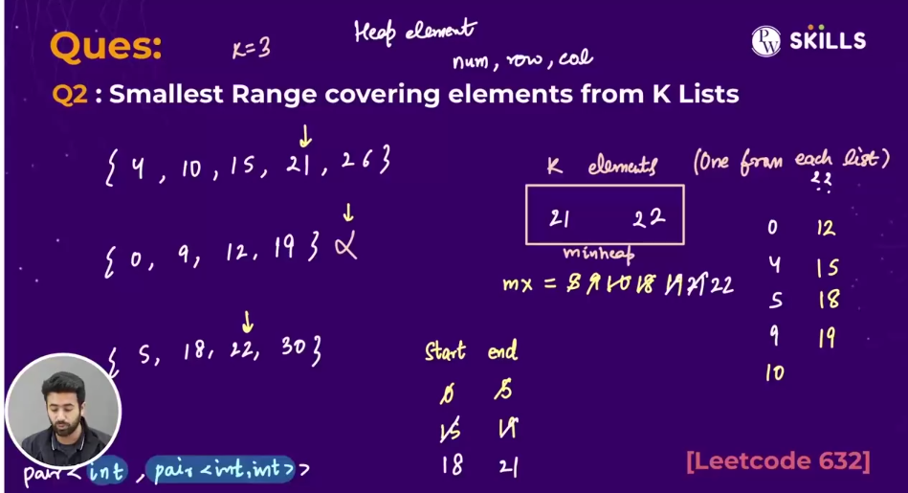🡪algorithm🡪pehle saare given vectors k 1st element ko ek minheap m store kr lo, and unka maximum element nikaal lo and by using the maximum element and minimum element , ek range bna lo 🡪 now from the minheap, jo sbse chhota element h, uske row and column index khi store kr lo and uspe present pointer ko aage badhaate jaoo, and usme se jo pehle maximum element h, and jo current element h, uska maximum nikaal lo and minumum minheap ka top waala eleement hoga, , dono ko old range k values m update kr do.
* Note: 
* 